

Project 2- Final Solution

Tech Crusader Consultant



July 10, 2019

Integrated Case Study - INFO8440

Team 4

Vaibhav Solanki||Ruhi Ruhi||Gayathri Soundrarajan||Gurpreet Singh||Narinder Singh

**Letter of Transmittal**

11th July, 2019

To,   
Senior BA  
INFO8440

CDL Limited  
Doon Valley,  
Kitchener, ON N2P 1T2.

Tech Crusader Consultant  
2899 Doon Valley Dr,  
Kitchener, ON N2G 4M4.  
[TechCrusader@work.com](mailto:TechCrusader@work.com)

Dear CEO Billy Bob

Thank you for considering Tech Crusader Consultant as the candidate to find an effective solution for your TRACKR project. We appreciate the trust you put in us. Our team are hereby submitting the final solution report which details out the plan to tackle the current TRACKR issue.

Our team, after considering multiple options to approach the problem, hereby submits the following documents: The study of current state which includes elements such as History and Challenges, As-Is process flow ; The predicted future state which includes major elements such as draft Website, Use case diagrams as well as site map; The implementation plan which includes elements like the Project Plan, Support plan as well as success criteria. The document contains also contains the concern as well as opinion on the website, SWOT analysis and the benefits of webtechnology.

Please consider that the documents attached along with the letter does not guarantee the success of the project, nor does it bind Tech Crusader to any obligation. Please feel free to contact us in case of any query or concern. We look forward to work with you.

Thank you for your time.

Vaibhav Solanki  
Project Manager

Statement of Confidentiality

The purpose of this draft document is to update CDL regarding the progress of the website development project. The documents address all the needs of CDL with an effective solution. All the documents and information that our team, Tech Crusader Consultant, received shall be kept confidential. All the information and document provided to us shall be treated as the property of CDL.

We, Tech Crusader Consultant, understand and acknowledge that it will be our responsibility to keep all information provided to us protected and confidential. Leakage or release of any document shall be considered as a breach of agreement.

We agree not to disclose the information provided to us with anyone. Release or Disclosure of information and document will result into legal consequences.

Signed By

|  |  |  |
| --- | --- | --- |
| Name | Role | Signature (Initials) |
| Solanki Vaibhav | Project Manager | V.S |
| Ruhi Ruhi | Communication Specialist | R. R |
| Gurpreet Singh | Scribe | G. S |
| Gayathri Soundrarajan | Program Manager | G. S |
| Narinder Singh | Scribe | N. S |

Document History

|  |  |  |  |
| --- | --- | --- | --- |
| **Title** | **Version** | **Modified By** | **Submitted On** |
| Draft Document | 1.0 | Vaibhav Solanki | 07-11-2019 |

Executive Summary

Conestoga Design Limited, hired a team for developing its website in 2004. The website was launched in 2004 designed by Kijiji freelancer. The website was outdated, non-appealing and just had the textual description of all the medical imaging products sold by CDL. Over the period of more than 14 years, the content nor the design on the website was changed. People even forgot that they had a website which had products that CDL no longer manufactured.

By reviewing every metric, CDL had overcome the issues of bankruptcy by conducting regular meeting. CDL found that the website company owned is not utilized properly as website was never completely integrated into the business strategy plan. After receiving the customers feedbacks from the informal survey, they revealed that layout of the website was confusing, not organized and content was very less. TrackR Social Media Marketing (TSSM) team were formed to improve the website to keep up the competition.

This document includes the following elements:

• Client background

• Current Situation

• Business need

• Strategy document

• Mock-ups and annotations

• Sitemap

• Process flow diagram

• Use case diagram

• Cockburn Use Case template

• Pseudo code

Table of Contents

Client Background 1

History of CDL 1

CDL Brand and it's Status 1

Persons involved with their roles 1

CDL Business challenges 2

KPI for CDL 2

Persona 3

Story Board 4

Opinions of Six Executive 5

Assessment of VP’s 6

SWOT for the executive team 7

CDL Operations Process 8

CDL As-Is Process 8

As-Is Call Center Process Flow 9

As-Is Sales and Marketing Process Flow 10

Scope 11

Clients Need, Deliverables and Action Plan 11

Website Features Benefits 18

Sign In option: 18

Store Finder: 18

Contact Information: 18

Social media link: 18

Product Filtering: 19

Chatbot 19

Application Team and Marketing Team Suggestions and it’s integration 20

Future States Process 21

CDL To-Be Process 21

Use Case 21

Cockburn Template 22

Process Flow 28

Site Map 29

Psuedo Code 30

First Draft Of Website 35

Wireframe 35

1.0. Home Page 35

2.0. About 36

3.0. Shop Online 37

4.0. Select Product 38

5.0. TrackR Product 39

6.0 MedImaging 40

7.0. View Cart 41

8.0. Checkout 42

9.0 Store Locator 43

10.0. Career 44

11.0. Terms and Condition 45

12.0. FAQ’s 46

13.0. Contact Us 47

Website Specification Document 48

Introduction 48

Purpose 48

Site Architecture 48

Site Design 48

Prototype and Annotation 49

E-Commerce Advantage and Disadvantage 64

E-Commerce: 64

Benefits of using E-commerce: 64

Drawbacks of E-commerce: 64

Challenges 64

Web Hosting Survey 66

Brief overview 66

Selection criteria 66

Our Pick: WHC 68

Request for Quotation 69

Introduction 69

Procedure for Bidding 69

Criteria and Constraints 69

Additional Information Requirement 69

Timelines 70

Features of Website 70

Time Estimates 70

Cost Estimation 70

Difference Between End-User’s and Customer’s 71

Definition of End User: 71

Definition of Customer: 71

Difference between End User and Customer: 71

Project Plan 72

Vision 72

Deliverables and activities 72

Collaboration Plan for Staff 73

Website Technology Education Plan. 74

Website Technologies Benefits and its Strategic Use 74

Productivity: 74

Faster Service and ease of use: 74

Better Communication: 74

Brand Image: 74

Training Plan 75

Human Resource Executive: 75

Finance Executive: 75

Facilities Executive: 75

Web Host Tech Support 77

The primary reason why our team would suggest to outsource the maintenance of the website are as follow: 77

Maintenance Process: 77

Risk Management Plan 79

Overview 79

Identifying Risks 79

Performing and Prioritizing risk assessment 79

Tracking and Monitoring 79

Risk Register 80

How website Technology will support CDL business process? 81

Tools and Techniques 82

Team Contract 82

RACI 84

WBS 85

Gantt Chart 86

References: 87

# Client Background

## History of CDL

In 1998, CDL started their journey by entering the business of manufacturing medical imaging scanner. 10 years later, CDL become the market leader in manufacturing and selling the medical equipment’s. CDL entered the business of portable fitness devices market by launching the TrackR device. After gaining initial success in the TrackR device the company began to suffer due to the application failure and customer complaints. Soon the revenue was down, and the company was facing bankruptcy.

In order to solve its crises, CDL decided to improve the application of TrackR device and relaunch the app along with establishing the social media channel to make their presence known and to reach to a maximum number of people. The project was a success.

CDL now wants to improve the prospect of the company by launching a new website which will be an e-commerce website, to boost the sale of the TrackR device as well as medical equipment by utilizing web technologies. CDL is currently undertaking the website development project.

## CDL Brand and it's Status

Primary brands involved in this project are:

TRACKR: TrackR wearable fitness is one of the key brand involved in the project

CDL: Conestoga Design Limited has its own reputation on the line, so it’s the major brand in this project

MedImaging: The medical imagining scanners is another brand involved in this project

Currently, CDL is facing financial crises despite overcoming the TrackR app problem. CDL needs to be restored to its former glory.

## Persons involved with their roles

* Senior Executive of CDL
  + CEO: Billy Bob runs the company CDL
  + Project Manager: In-charge of all the project works
  + Facilities VP: In charge operation and maintenance of facilities
  + Marketing VP: In charge of marketing the products. Controls and provides direction to the marketing team
  + IT VP: In charge of handling the IT infrastructure of CDL
  + HR VP: In charge of hiring and firing CDL employees.
  + Production VP: In charge of production operations of TrackR and imaging scanning equipment’s
  + Finance VP: In charge of managing the finance of the company. Generates funds for the company.
* Website Development Team: In charge of developing the new website for CDL
* TrackR App Development Team: TrackR application development team which developed the TrackR app. Will provide ideas for website development
* Business Analyst Team: In charge of providing an effective solution for CDL problem’s
* Big Box Retailer: Buys CDL products and sell to the end user
* Sales Team: In charge of selling the products
* End User: People currently using CDL products. Also includes people who will be using the website once it's developed to buy the product.

## CDL Business challenges

* CDL is currently facing financial crises, barely managing to pay the suppliers and payroll cheques.
* CDL top management are not on the same page regarding the technical changes happening at CDL
* In urgent need to fix the website
* No website development team to develop the website
* Identify the way to increase their revenue by selling more medial scanning equipment and TrackR device to avoid bankruptcy
* Train the VPs of the company about the use of web technologies
* Top management lack of skills to manage the business
* Improve the brand reputation

## KPI for CDL

Billy Bob – the CEO of the company, measured the success of CDL on two criteria. They are: Continuous expansion of company and sales quantity of TrackR and medical scanning equipment. Billy Bob failed to understand that they are a lot of factors that need to be considered as key metrics for running a successful business for a longer period of time. The factors identified as the metrics or KPI as an indicator of corporate health turned out to be false. Now the company is facing bankruptcy.

# Persona

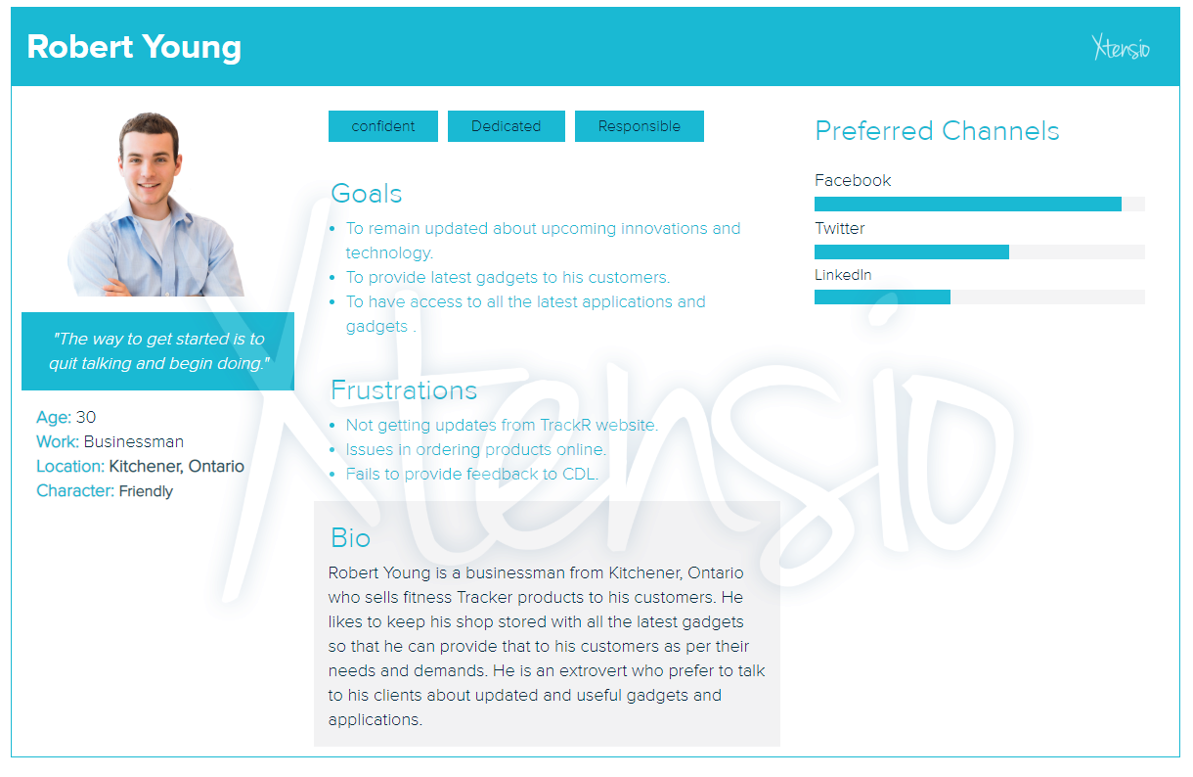

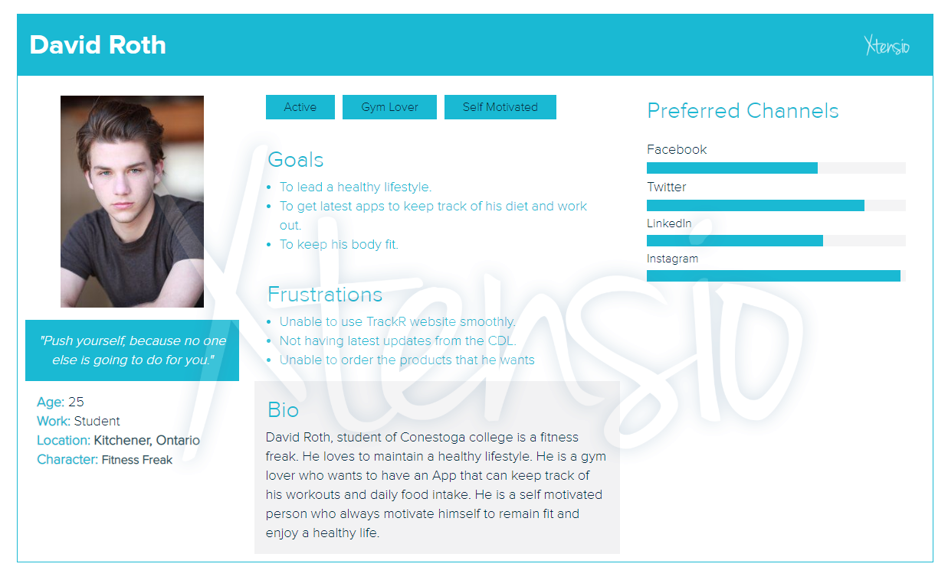

# Story Board

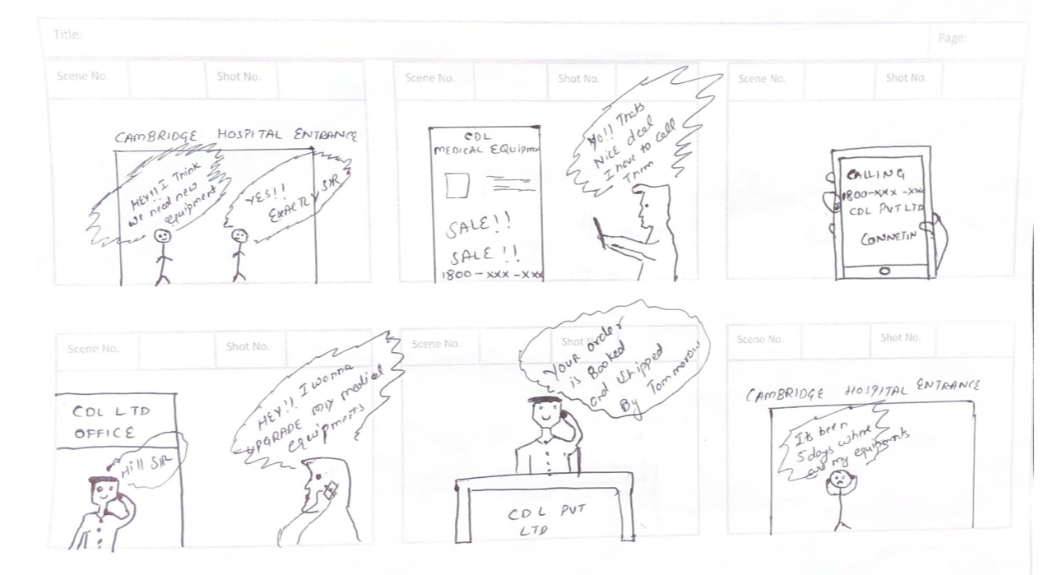

# Opinions of Six Executive

Based on the interview summary, the opinions of the 6 executive were given below

**Finance VP**

* Wants the DASHBOARD and willing to cooperate
* He is conducive to change
* Knows the root case why TRACKR is not looking good and ready to co-operate more in this website development

**Production Lead**

* Willing to cooperate and change
* Wants the DASHBOARD and training facility for the website
* He also demands that new hires must have a knowledge about assembling, production and also Computer knowledge
* He also insists that the executives must meet twice in a week so that HR an IT also understands how the company operates

**IT head**

* As he having computer knowledge and knows the root cause of the problem he would like to hire a developer team for TRACKR
* Wants a DASHBOARD who provided data for the dashboard
* He also wants call center to be automated

**Marketing Head**

* Cooperative but is being pushed
* Marketing head supervises the call center and wants Facilities and HR executive to be more trained and co-operative
* He implies change management

**HR head**

* He is not co-operative and worried about the attrition rate and claimed that production/marketing are not doing their jobs
* Worried about attrition rate

**Facilities Guy**

* He is less cooperative
* According to him wearable technology is a big mistake and CDL must stop wearable tech business
* Finally, he would like to know how the company works
* Against Finance department suggestions

# Assessment of VP’s

|  |  |  |  |  |  |
| --- | --- | --- | --- | --- | --- |
| **Executives** | **Computer Knowledge** | **Training** | **Metrics needed** | **Acceptable Range** | **Graphics versus Numbers** |
| **HR** | Has Computer Knowledge | Training not required | Benefits and Incentives/ Payroll/ Hour/ Finance Payouts | -- | G |
| **Finance** | Has Computer Knowledge | Requires Dashboard | Customer Payments, Duration customer takes to pay | Above $60,000 | N |
| **Production** | Less Computer Knowledge | Wants training | Cash flow, Production Rate, Error Rate, Quality control and shipping | 5000 units minimum | N |
| **Facilities** | No/Less | Required training | Finance Based Metrics for facilities | -- | G |
| **IT** | Has computer Knowledge | Training not required | Customer feedback/Finance/HR/Production/Facility | -- | N |
| **Marketing** | Has computer knowledge | Wants HR and facilities executive to be more trained | Retailer Support/ people leaving marketing job/ Financial metrics like cash flow | -- | G |

# SWOT for the executive team

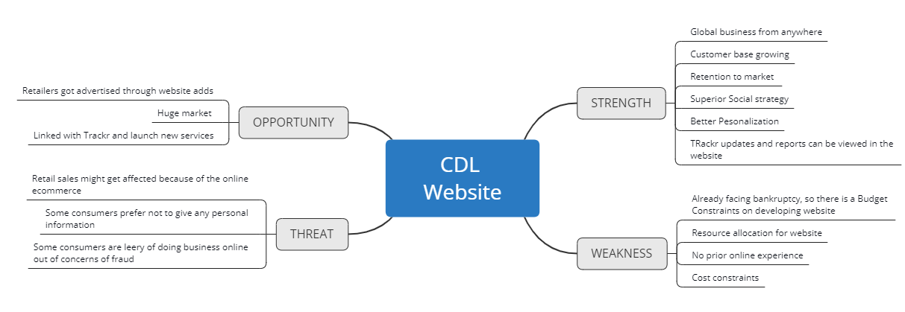

# CDL Operations Process

## CDL As-Is Process

Our team analyzed the documents provided by CDL about its process of managing and processing orders, Marketing and supply chain process. Our team identified that CDL didn’t follow any detailed and specific process for order processing, marketing, and supply chain process. Order processing is done via a call center, marketing is done through news adds and news pamphlets, while supply chain process is unknown.

After a thorough analysis of the operational processes at CDL, our team reached the conclusion that none of the materials or process can be utilized. Our team suggests starting a fresh operational process which is result oriented and detailed. The old traditional methods followed by CDL were outdated and needs a major upgrade to compete in the market.

The As-Is Call customer service process through call centre and the sales and marketing process is explained with the help of process flow diagram for better understanding. The process flow takes a lot of time and there is always a long waiting queue which frustrates the customer.

## As-Is Call Center Process Flow



## As-Is Sales and Marketing Process Flow



# Scope

## Clients Need, Deliverables and Action Plan

1. Need:
   * Assessing the critical knowledge of 3 executives about website technologies and strategic uses.

Deliverable:

* + Drafting a custom training plan which includes the goals and educates the executives about the critical importance of website technologies and its impact in the decision making the process for the website development project

Action Plan:

* + Firstly, our team will perform the elicitation to identify the current knowledge of all the executives (except the marketing VP). Secondly, based on the current knowledge, our team will shortlist 3 executives who would be further trained on how the website technologies can help them take critical decisions.
  + Our team will also develop a training plan which will be followed while training the executives on the benefits of the web technologies.

1. Need:
   * Gather the opinion, thoughts, and concern of the executives about the technical changes in the company and about the website development project.

Deliverable:

* + Perform SWOT analysis based on the stakeholder elicitation result.

Action Plan:

* + Our team will perform elicitation and meeting with all the VPs. Our focus will be to gather the perspective and feeling of each VPs towards the current technical changes happening at CDL. Based on the result and answered gather and analyzed, our team will perform SWOT analysis. Elicitation will not only help our team to gather the opinion of all VPs but it will also provide our team with an insight into how we will have to manage the stakeholders further in the project.

1. Need:
   * Collect the ides of the marketing team about the website features that might be able to satisfy the needs of the existing customer.

Deliverable:

* + Gather the idea and document that idea.
  + Analyze those ideas provided by the marketing team and draft a document suggesting the ways those ideas can be utilized.Action Plan:
  + Our team will conduct a meeting with the marketing team. Each member will be allowed to speak their mind and the ideas will be documented. Once the ideas are documented, our team will verify the document with the marketing team to avoid any confusion and misinterpretation.
  + Once the ideas are documented, our team will analyze the ideas and provide suggestions for the utilization of ideas with the website development project.

1. Need:
   * Collect the Ideas and request of TrackR App upgrade project team about the website.

Deliverable:

* + Collect and Document the request of TrackR App Upgrade team.
  + Analyze those request and draft a document suggesting how those request and ideas can be utilized.

Action Plan:

* + Our team will conduct the meeting with the TrackR App team to gather the ideas and listen to their request. All the request will be documented and analyzed. Our team will develop a document after analyzing the request and provide a suggestion about the ways in which those ideas might be utilized.

1. Need:
   * Provide some suggestions of the features that might benefit CDL.
   * Provide the numerical projection impact of the features.

Deliverable:

* + Draft a document which lists the features that might benefit CDL. Explain the benefit in detail and provide the estimated numerical projection about the impact of those features.

Action Plan:

* + Firstly, our team will identify the list of features that might be beneficial for the website. Secondly, our team will analyze the impact of each feature, along with estimated numerical projections of each feature. Everything will be documented for further reference and prioritization of the features.

1. Need:
   * Document the current marketing, order processing, and supply chain procedure and process.
   * Provide suggestion to the executives on how website technology can benefit in the current operations and simplify or streamline those operation process.

Deliverable:

* + Draft a document, documenting the current marketing, order processing, and supply chain process.
  + Clarify if the website will be e-commerce or support or both.
  + Provide suggestion about the reuse of marketing material for website development.

Action Plan:

* + Firstly, our team will study the current marketing, order processing, and the supply chain process, operation, and procedure of CDL (Document is yet to be provided to us by CDL).
  + After studying the document, our team will identify the ways to support, streamline and improve the current operation by using web technologies.
  + Our team will also clarify that the new website will be an E-commerce website along with some additional functions. Also, our team, after studying the documents, will determine if the marketing document can be reused to help the project.

1. Need:
   * Develop AS-IS profile for TrackR Marketing, Sales and EndUser Support.
   * Identify the risk involved with the website development project

Deliverable:

* + Develop AS-IS profile for TrackR Marketing, Sales and EndUser Support.
  + Draft a document for executives suggesting how the website technologies can be utilized to boost the sells of the device. Also advising the executive on how the end user can be provided the support with the help of website technologies.
  + Draft a document identifying the risk involved.

Action Plan:

* Our team will prepare an AS-IS profile of the marketing, order processing, and supply chain operations. This will allow CLD to have a clear view of how each process or operation is processed or operated.
* Our team will also advice CDL on how new web technologies can help them boost the sell of the device. Also, we will update CDL about the risks involved in the project.

1. Need:

* Differentiate the difference between end users and customer.

Deliverable:

* Marketing VP is confused about the difference between end user and customer. Clarify the difference and solve is confusion by drafting a document explaining the difference between end user and customer.

Action Plan:

* Our team will distinguish the difference between the end user and customer along with some example to clear the confusion.

1. Need:

* Prepare a Request of Quotation for hiring the website development team either on a contract or full time

Deliverable:

* Draft a document identifying the skills and knowledge that the website development person should possess to qualify for the job.
* Provide the estimated quotation for hiring the development team

Action Plan:

* Our team will first identify the skills and knowledge that one individual should possess to qualify as a potential candidate.
* Once the skills are identified, we will research the current market wage that a candidate with identified skills might demand.
* Everything will be documented along with the total estimated cost required to hire a development team
* Suggestion on whether to hire on a contract or full time will also be included as a part of the document.

1. Need:

* Develop a first draft prototype for the website

Deliverable:

* Draft a prototype for a website which includes the working functions and features.
* Include the Pseudocode, element list and all the supporting documents needed.

Action Plan:

* Firstly, all the features that will be part of the website will be identified before developing the prototype.
* Once the features are decided, our team will draft the first prototype that will include all the functional features in it. Less attention to details will be given to the specs, font, and navigation and more attention will be paid to integrate all the functional features of the website.

1. Need:

* Develop a second draft prototype for the website

Deliverable:

* Develop the second draft prototype, providing the details set of specification for the website.

Action Plan:

* Once the first prototype version is developed, our team will first test that prototype and find areas of improvement and simplification
* After analyzing the first drafted prototype, our team will move towards the development of the second prototype draft. More focus will be paid towards the Specs and standards.

1. Need:

* Draft the document for the prototype elements listing.

Deliverable:

* Develop an excel workbook, listing all the needed website elements, assigning them unique ID #’s.

Action Plan:

* All the elements will be listed and each and every element will be assigned a unique identification number

1. Need:

* Draft a document that has a list of all the elements of the website. It should contain the estimated time to produce each type of element

Deliverable:

* Draft a document which has the list of all the elements of the website. It should contain the estimated time to produce each type of elements, the labor rate of a developer, and the total estimated cost of website development. This document will be treated as the base for acceptance testing.

Action Plan:

* The time required to deliver each element of the website will be estimated and documented.

1. Need:

* Draft the plan for CDL staff which helps them to provide the content for the new website.

Deliverable:

* Draft a project plan to integrate the ideas and content of CDL staff in the website development project. the developing team will be utilizing the document to develop and test the website.

Action Plan:

* Our team will identify the way for the CDL staff to contribute their ideas for the website development project. All the ideas will be documented which will be utilized by the website development team to integrate a few of the suggestion in the website development plan.

1. Need:

* Provide the details about different web hosting options, that are Canadian.

Deliverable:

* Draft a document advising CDL, in details, the different hosting option available. The document should be in the form of a survey and comparison of three potential Canadian website hosts. Also, provide the projected cost for two years to host the website.

Action Plan:

* In order to meet this requirement, our team will research on the different website hosting options available.
* A survey will be conducted to gather opinion and for comparison of different hosting option. Few criteria’s will be defined and 3 best website hosting option will be evaluated. The document will also include the estimated hosting cost for two years.

1. Need:
   * Provide a solution for Tech support.

Deliverable:

* + Draft a document suggesting the way in which the tech support will be provided after the implementation of the website. Suggest the solution for long term maintenance and updates of the website.

Action Plan:

* Our team will prepare a document identifying a way to provide tech support and up-gradation of the website on timely bases so ensure the maintenance of the website.

1. Need:

* Possible future analysis and development plan.

Deliverable:

* Draft a document identifying the possible future improvement that could be made to future improve the prospect of CDL.

Action Plan:

* Our team will research and analyze the ways in which the website might further be
* improved. All the ideas will be documented for future reference.

# Website Features Benefits

Sign In option:  
Sign in option, usually located at the upper right corner of the webpage allows the user to store their data such as an address, preferred credit card details and many more. User can save the product that they like on their wish-list and purchase later. Sign In option saves a lot of time for the users as they don’t have to enter their address and other details when they purchase any product.

Moreover, from the business point of view, Company can identify the loyal customers, providing them some special discounts, share newsletters, view their wish-list, customize their needs, add them to the loyalty program and much more. Registered users are allowed to post reviews and rate the product they purchased, thereby building a strong connection with the company. User’s feedback helps the company to get an insight into its service and find areas of improvement.

Projected impact of these features is unknown, but our team is convinced that adding this feature to the website will help the company improve its service and provide better customer service.

Store Finder:  
CDL sells its products to all the major big box retailers. Many customers prefer to observe and test the product before they buy. This particular feature helps the customer to locate the store nearby, where he/she can go and physical test the product before placing the order.

Sales of the products are likely to increase up to 10%-12%.

Contact Information:  
Whether it be enquiring about a particular product or clarifying business hours, customers may need to contact the company for various reasons. Customers get irritated when they can’t find any contact details of the company when they have any queries or concerns. Mentioning the contact number at the top makes this easy for them to contact the company and solve the doubt.

Sales likely to increase up to 5% and an increase in customer service and customer satisfaction up to 8%

Social media link:  
Customer can follow the company on social media and be aware and updated about the latest offers, products, and trends. Integrating social media icons on the company’s website is a great way to market your product and to encourage any potential increase in sales. Presence of Social media accounts is an effective way to set up more interaction with customers and potential customers, in turn increasing the interest in any products and services and potentially leading to increased sales.

Boost to Brand Image, Increase in web traffic up to 15%, Increase of sales up to 7%.

Product Filtering:  
Product filtering allows customers to filter products based on different attributes. For example, a clothing store may use gender, size, color, etc. as its filtering options. Customer’s or users can sort the list based on different attributes such as price, arrival or discounts. This feature allows the customer to search for the desired product without wasting much of the time. Users and customers get very frustrated when they had to go through a long list of products.

Customer satisfaction is likely to increase by up to 10%.

Chatbot Assistance:  
Chatbots are simply computer programs designed to mimic a normal human conversation. This chatbots are simple to design and can be integrated with websites or Apps. Simple Chatbot assistance can help a business achieve better customer service, reduces time, and saves money. Simple Chatbot assistance can be developed in which all the commonly asked questions along with the response will be stored. The chatbot will identify keywords from the visitor and provided an appropriate response to the query.

Reduces Customer wait time by up to 25%, up to 15% cost saving as CDL can reduce the employees working as customer service representatives, Boost in brand image.

# Application Team and Marketing Team Suggestions and it’s integration

TrackR application team suggested to develop two FAQ’s document; first FAQ’s will be very detailed one which will not be published on the website while other FAQ’s will be just commonly encountered questions with the stepwise solution which can accessed by end user through the webpage. Both of the document will be updated from time to time as new and additional information emerges.

TrackR team request turned out to be perfect for the solution of the webpage. We integrated the idea and created a separate page where end user can access the commonly asked question along with its solution. This feature will improve customer service, reduce traffic on the customer support line and provide quick effective solution.

While we honored the TrackR Upgrade team idea as it perfectly suits the design, the marketing team idea was outdated and was discarded.

# Future States Process

## CDL To-Be Process

Our team will streamline and simplify the operations process by making use of website Technologies and strategies. The order processing will be simplified by developing an E-commerce website. The tech support for medical as well as TrackR will be simplified by publishing FAQs and utilizing an assistance bot which will have the answers of common queries and questions of end users and customers. Website Technology and its features will simplify CDL operations, resulting in less workload, fewer errors and better customer service.

## Use Case



## Process Flow



## Site Map



## Psuedo Code

Onclick Home Button

Then Load Page

Do Get Promocode for TRACKR

else

If OnClick Shop Online

Do Onclick medical Equipments then

OnLoad medical equipments screen

OnSelect IconOn product 1

WHEN product 1 EQUAL your requirement

THEN OnSelect Product 1

WHEN product 2 EQUAL your requirement

THEN OnSelect Product 2

WHEN product 3 EQUAL your requirement

THEN OnSelect Product 3

WHEN product 4 EQUAL your requirement

THEN OnSelect Product 4

Do ONclick Shop online

Do onselect product

Do Enter quantity

Do Onselect Add to Cart

Elseif

Then Customize

Do OnSelect Microsoft outlook

Do Send Email customization

Do Enter Quantity

Then OnSelect Add to Cart

Then View Cart to confirm

Then Load Checkout page

Do checkout with paypal

Else

Do Load Continue Shopping

Do ONclick Shop online

Do onselect product

Do Enter quantity

Do Onselect Add to Cart

Else

Do OnSelect TRACKR

Then OnClick Buy

Then View Cart to confirm

Then Load Checkout page

Do checkout with paypal

Do get 20% off

Do use PROMOCODE 1SAD2

Endif

OnLoad Store Locater

View Map

Locate Store nearby

IF onselect BackButton

Then Load Homepage

Else if

OnSelect FAQ

View Frequently asked Questions

Onselect questions

View Answers

OnClick next questions

View answers

IF onselect BackButton

Then Load Homepage

Endif

Onload Contact page

VIEW Customer Support

If OnSelect Lets Chat bar

View Chat window

Else

Do Direct Message or Email us

Do Enter message

Do enter name

Do Enter subject

Do Enter message

Then Onclick Submit

Endif

OnLoad Facebook icon

VIEW Facebook profile

IF OnSelect Home icon

THEN Load Home Page

ELSE IF OnSelect twitter icon

THEN Load Home page

ELSE IF OnSelect Instagram icon

THEN Load Instagram CDL page

ELSE IF OnSelect pinterest icon

THEN Load CDL pinterest page

ELSE IF OnSelect youtube icon

THEN Load CDL page

ELSE IF OnSelect home icon

THEN Load home page

END IF

OnLoad Terms and Conditions Page

View Customer care conditions

View wholesale enquiries

View Payment methods

ELSE IF OnSelect home icon

THEN Load home page

Endif

OnLoad Career page

Select Onclick apply

ELSE IF OnSelect home icon

THEN Load home page

Endif

Onload User page

Do onselect subscribe to site

Do Enter First name

Do enter Last Name

Do enter Last name

Then Onclick Check box Want to subscribe

Do onclick Submit

ELSE IF OnSelect home icon

THEN Load home page

# First Draft Of Website

## Wireframe

### 1.0. Home Page

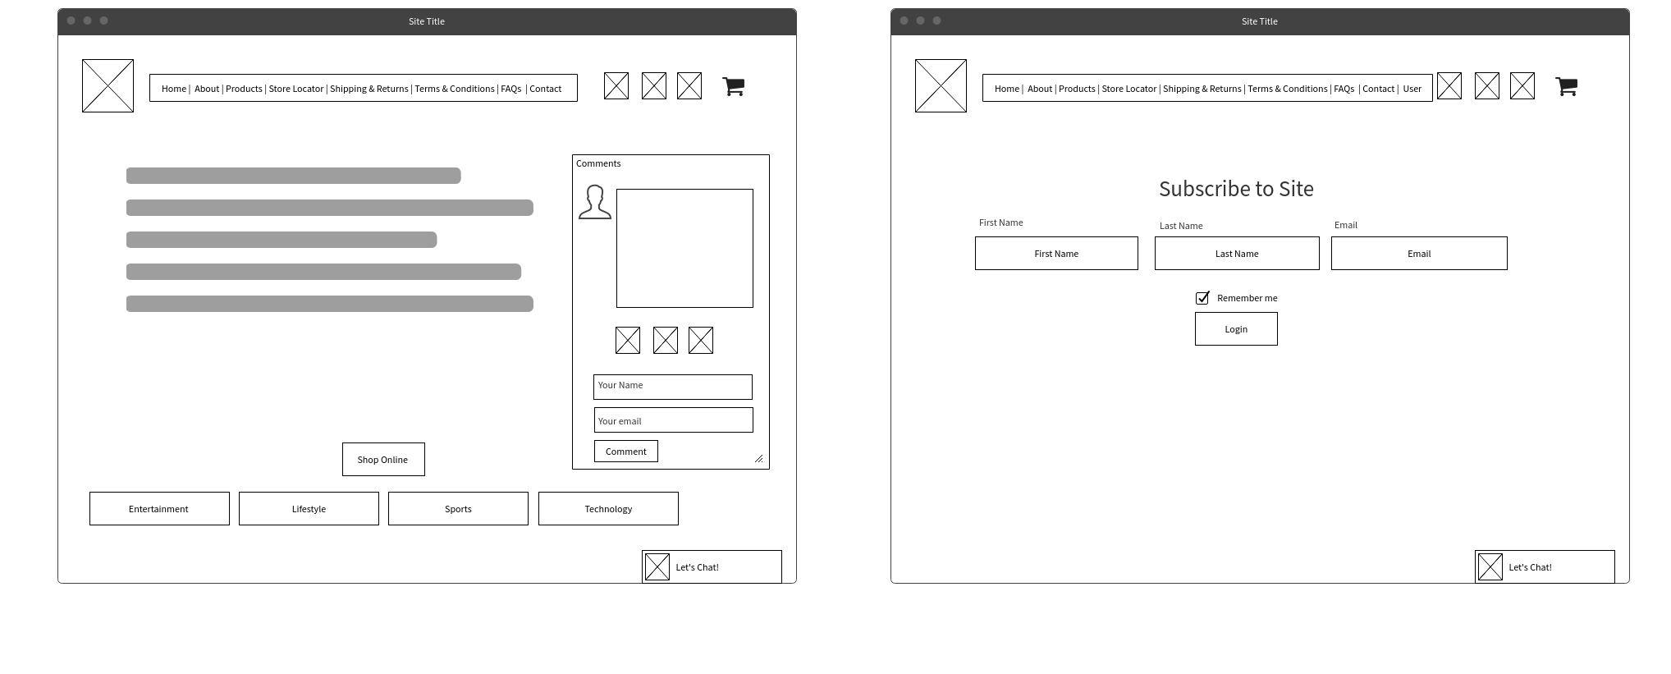

### 2.0. About

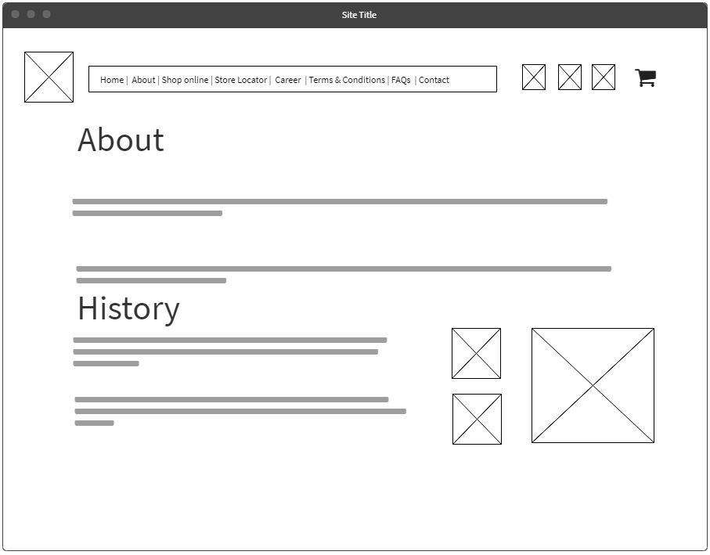

### 3.0. Shop Online

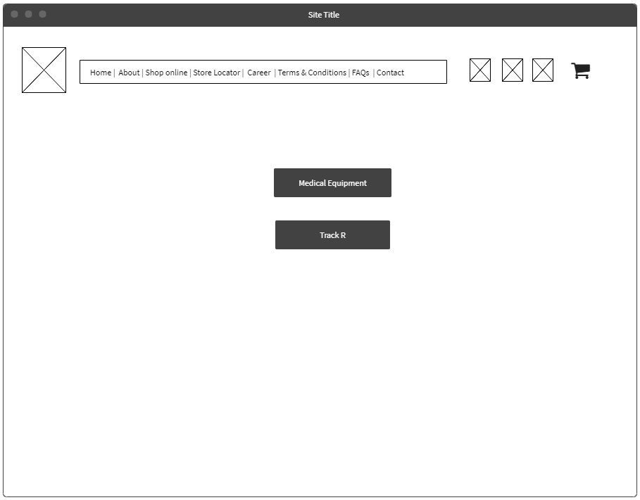

### 4.0. Select Product



### 5.0. TrackR Product

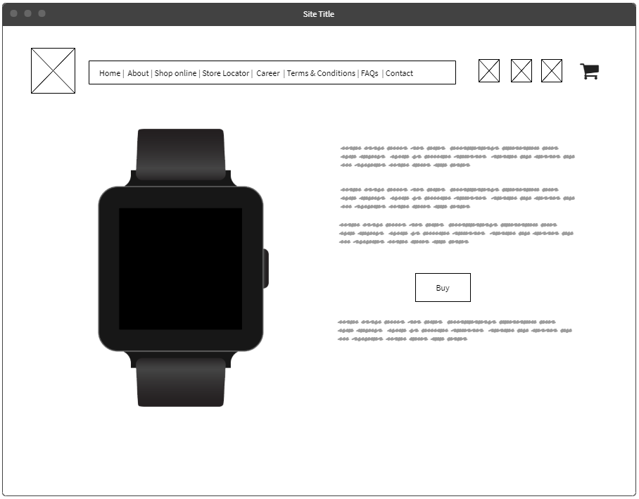

### 6.0 MedImaging

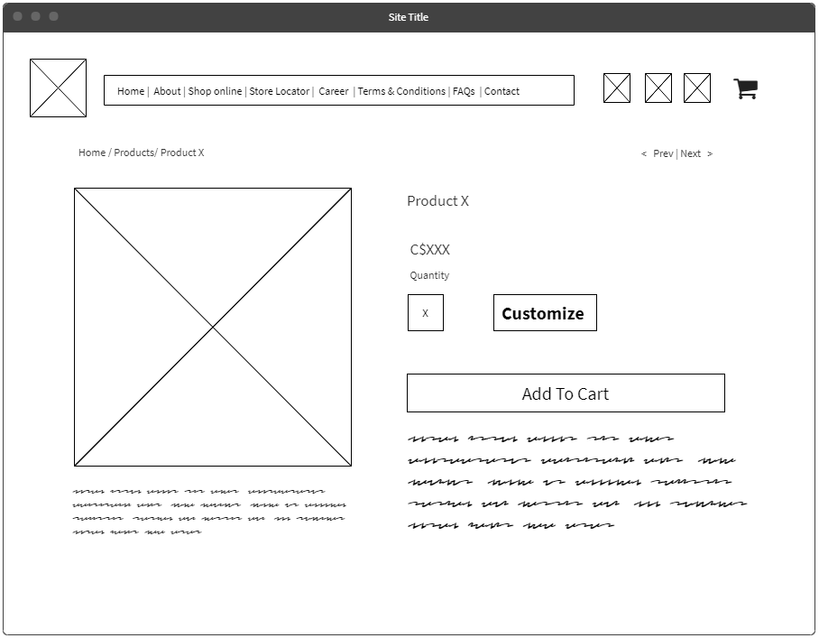

### 7.0. View Cart

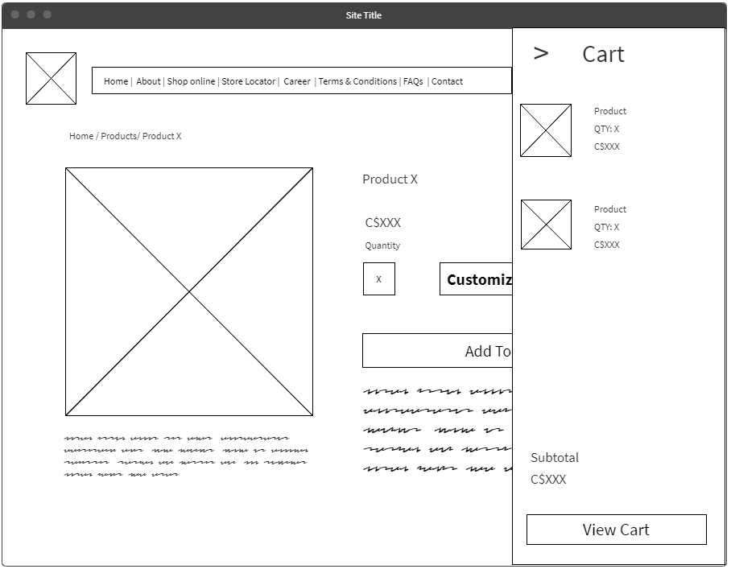

### 8.0. Checkout

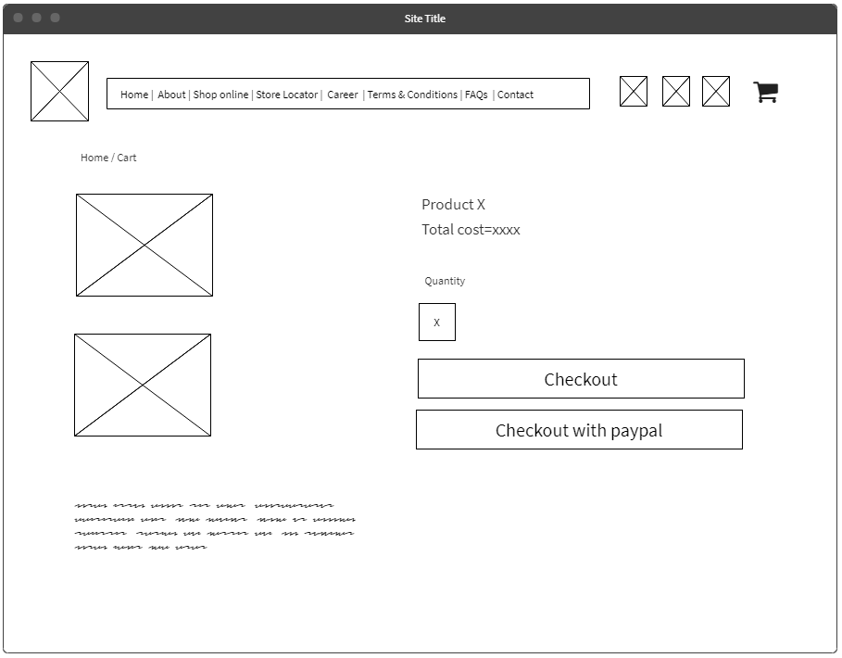

### 9.0 Store Locator

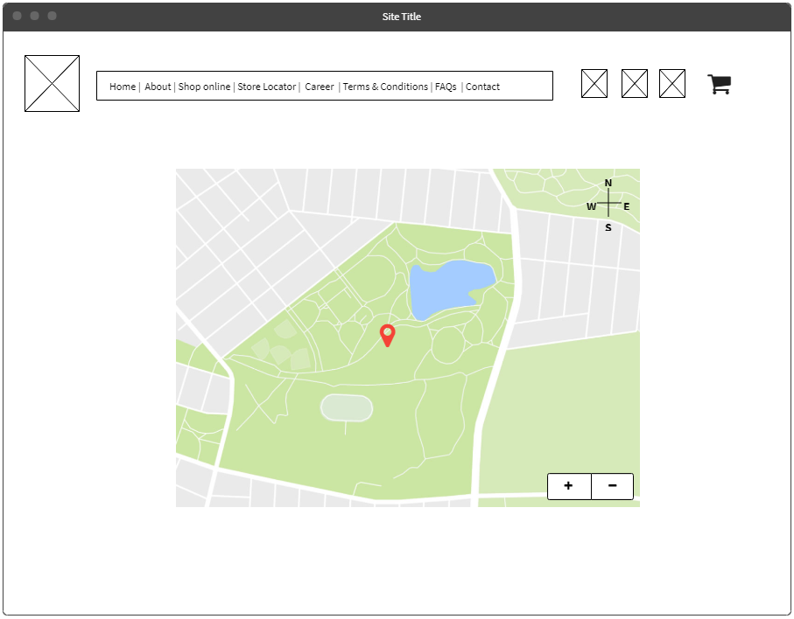

### 10.0. Career

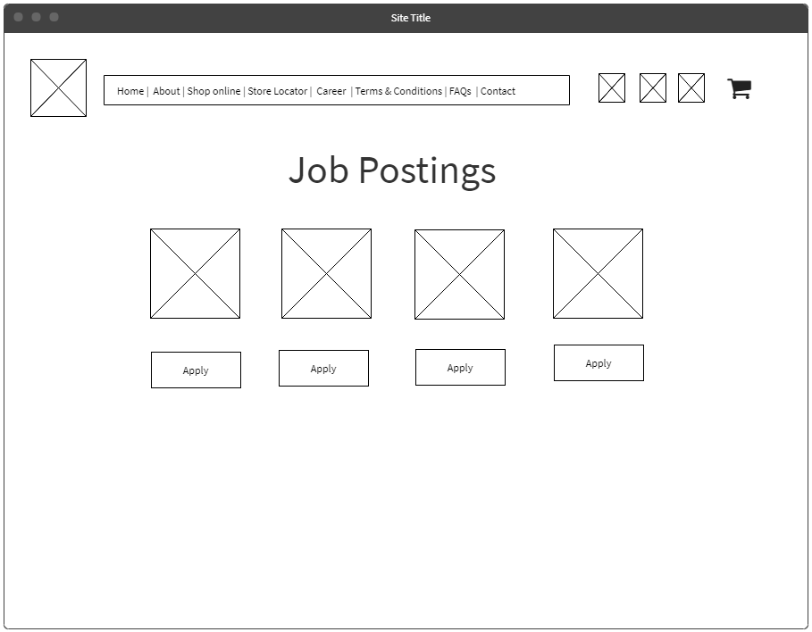

### 11.0. Terms and Condition

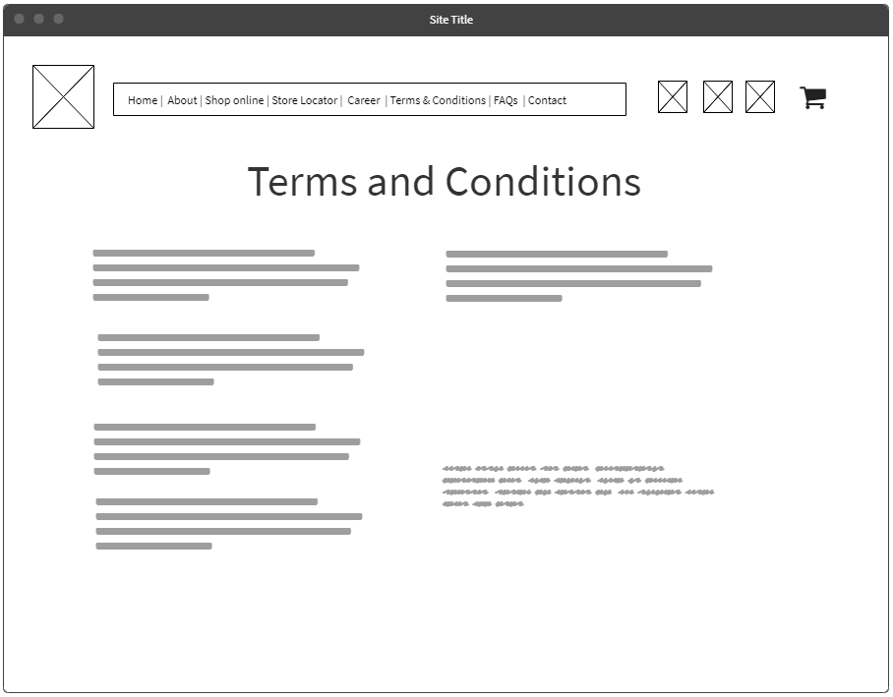

### 12.0. FAQ’s

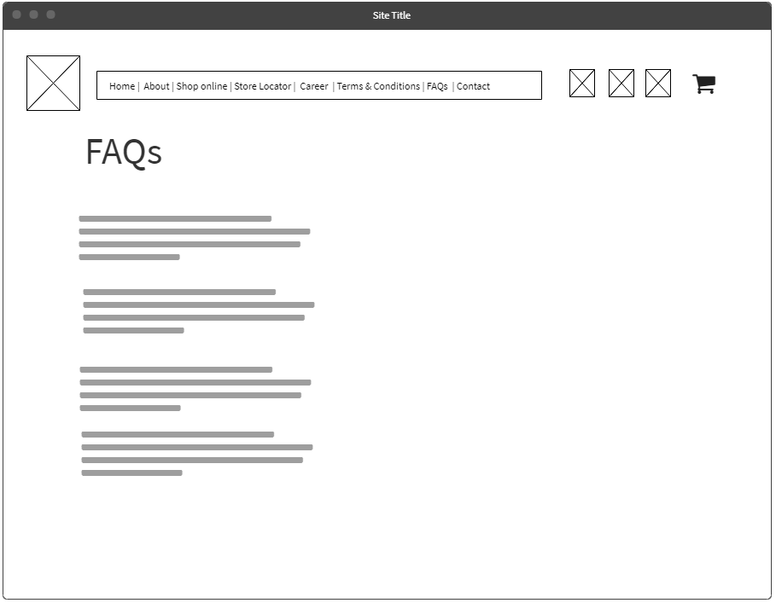

### 13.0. Contact Us

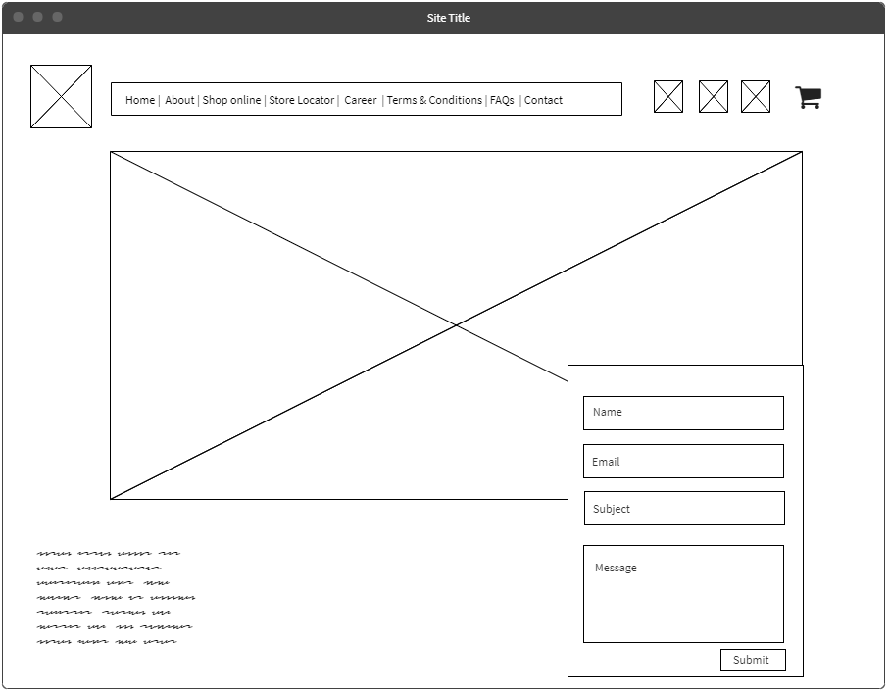

# Website Specification Document

## Introduction

The website specification document aims at detailing the outline and inner elements of every page of the website. In addition to the elements and the website components, the details on how the graphics and text as well as the content on the website has been laid out has also been documented.

## Purpose

The purpose of this document is to project the vision for the new upcoming websites and its features, not just for the users who will be using, but also for the developers who will be developing and maintaining it. This also puts more clarity on the outcomes of the project from the start.

This website documentation has been categorized into three categories

1. Site architecture
2. Site design
3. Page copy

## Site Architecture

The site architecture, as the name implies, takes into consideration various elements such as:

1. Navigation: Our website follows the ‘Hierarchical website navigation’ that provides a clear, simple path to all the web pages from anywhere on the website. Navigation will be simpler and each pages will contain graphics as well as text contents. Please refer to the process flow to review the interconnectivity of the web pages.
2. Page elements: The following page elements are a part of our website
   1. Sidebars
   2. Search bars
   3. Text fields
   4. Footers
   5. Widgets
   6. Social media page
3. Functionality: The features and its benefits have been explained previously under the section: ‘ Features that may benefit CDL’.

## Site Design

The website has been designed with the focus on creating an e-commerce website for medical imaging and equipment and CDL. Website will not only boost the sale of CDL product’s, but will also provide a new identity and boost the brand image of the company. Our team developed an appeal website prototype which is easy to navigate, user friendly, integrated with features such as an automated chatbox assistance, easy one click buy options as well as an option to place customized order. Website is rich in terms of text, graphics and content. Website will also highlight the proud history and culture at CDL, creating a new identity for CDL. The proptype design will provide the brief idea regarding the attractive and appeal website.

## Prototype and Annotation

<https://nmahal94.wixsite.com/mysite>

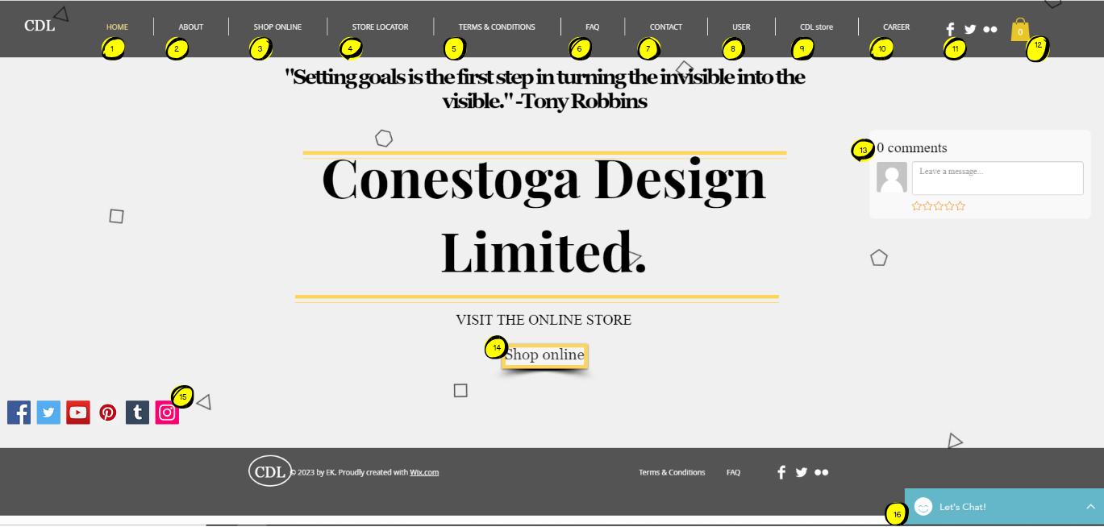

|  |  |  |  |  |
| --- | --- | --- | --- | --- |
| Number | Object Type | Default Text | Behaviour | Comments |
| 1 | Button | Home | Touch/Click | Display home page of website |
| 2 | Button | About | Touch/Click | Display Company detail page of website |
| 3 | Button | Shop Online | Touch/Click | Display Products page of website |
| 4 | Button | Store locater | Touch/Click | Display Products page of website |
| 5 | Button | Terms and conditions | Touch/Click | Display t and c page of website |
| 6 | Button | FAQs | Touch/Click | Display FAQs page of website |
| 7 | Button | Contact | Touch/Click | Display Contact details of company page of website |
| 8 | Button | User | Touch/Click | Display User page of website |
| 9 | Button | CDL Store | Touch/Click | Display all items |
| 10 | Button | Career | Touch/Click | Display Job posting of company |
| 11 | Icon | Social Platforms | Touch/Click | Social Platforms |
| 12 | Button | None | Touch/Click | Display Cart items |
| 13 | Text box | Leave a message | Touch/Click | Help to enter the message |
| 14 | Button | Shop online | Touch/Click | Display products page of website |
| 15 | Button | Social Platforms | Touch/Click | Social media platforms link |
| 16 | Button | Let’s Chart | Touch/Click | Chat Support |

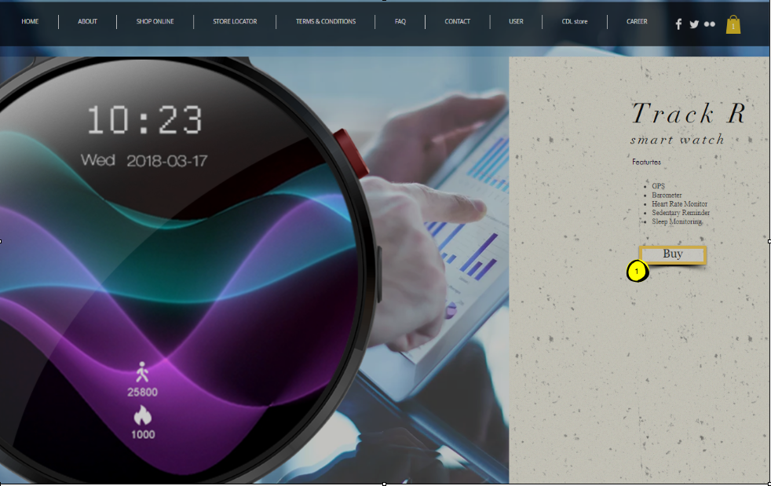

|  |  |  |  |  |
| --- | --- | --- | --- | --- |
| Number | Object Type | Default Text | Behaviour | Comments |
| 1 | Button | Buy | Touch/Click | Add to Cart Product |

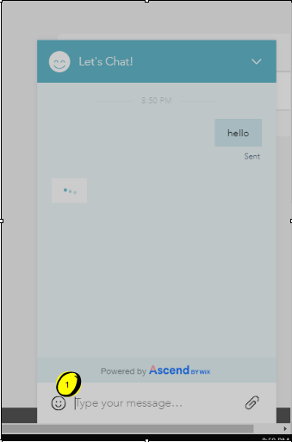

|  |  |  |  |  |
| --- | --- | --- | --- | --- |
| Number | Object Type | Default Text | Behaviour | Comments |
| 1 | Button | Type your message | Touch/Click | Start Chart with Customer care |

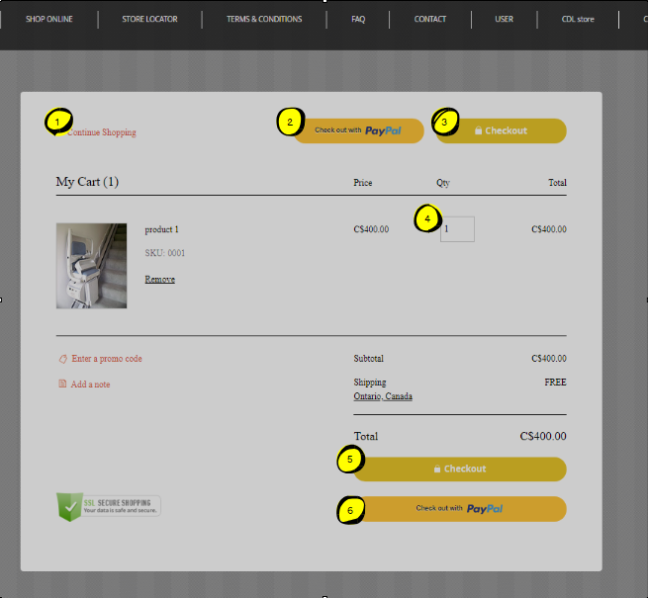

|  |  |  |  |  |
| --- | --- | --- | --- | --- |
| Number | Object Type | Default Text | Behaviour | Comments |
| 1 | Button | Continue Shopping | Touch/Click | For going back to Products |
| 2 | Button | Check out with PayPal | Touch/Click | Takes to PayPal page |
| 3 | Button | Check out | Touch/Click | Payment methods |
| 4 | Text Input | None | Touch/Click | Enter number of items |
| 5 | Button | Check out | Touch/Click | Payment methods |
| 6 | Button | Check out with PayPal | Touch/Click | Takes to PayPal page |

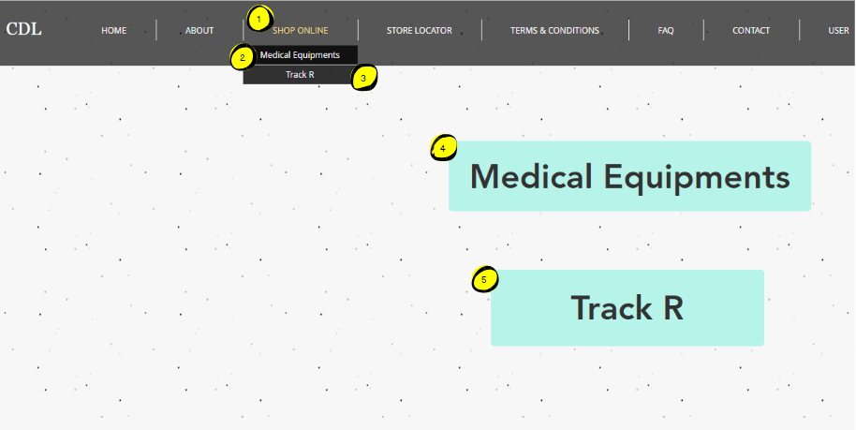

|  |  |  |  |  |
| --- | --- | --- | --- | --- |
| Number | Object Type | Default Text | Behaviour | Comments |
| 1 | Button | Shop Online | Touch/Click | Opening shopping menu |
| 2 | Button | Medical Equipment’s | Touch/Click | Takes to all medical products |
| 3 | Button | Track R | Touch/Click | Links to Buy Track R Page |
| 4 | Button | Medical Equipment’s | Touch/Click | Takes to all medical products |
| 5 | Button | Track R | Touch/Click | Links to Buy Track R Page |

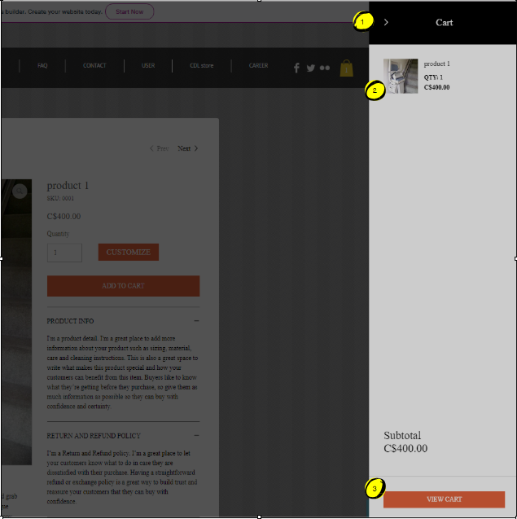

|  |  |  |  |  |
| --- | --- | --- | --- | --- |
| Number | Object Type | Default Text | Behaviour | Comments |
| 1 | Button | None | Touch/Click | Close cart |
| 2 | Button | None | Touch/Click | Takes to all medical products |
| 3 | Button | View Cart | Touch/Click | Links to Cart Page |

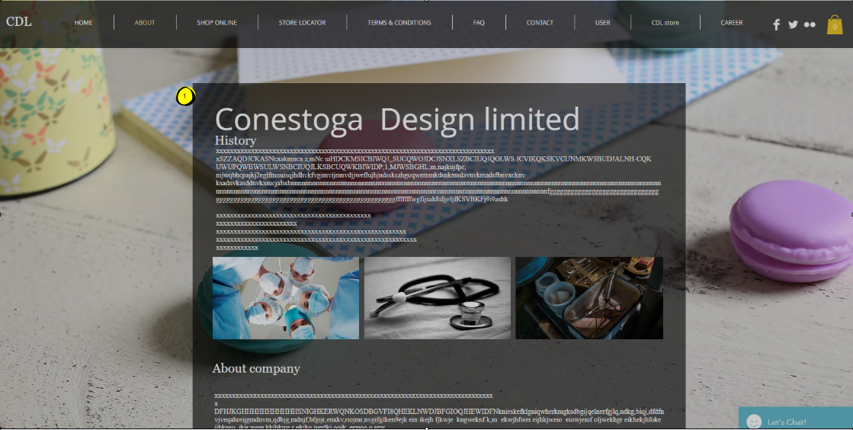

|  |  |  |  |  |
| --- | --- | --- | --- | --- |
| Number | Object Type | Default Text | Behaviour | Comments |
| 1 | Text | None | None | CDL History Page |

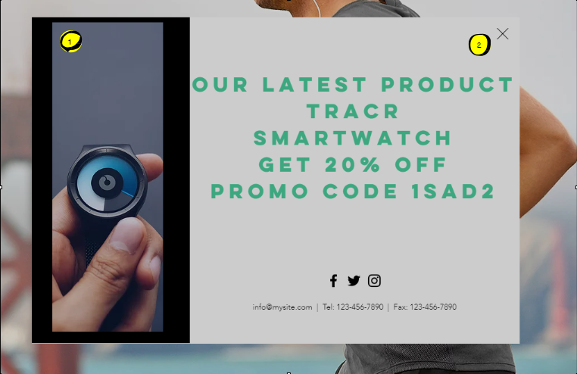

|  |  |  |  |  |
| --- | --- | --- | --- | --- |
| Number | Object Type | Default Text | Behaviour | Comments |
| 1 | Pop up | None | Pop up | Promotional Page |
| 2 | Button | None | Touch/click | Close the promotional page |

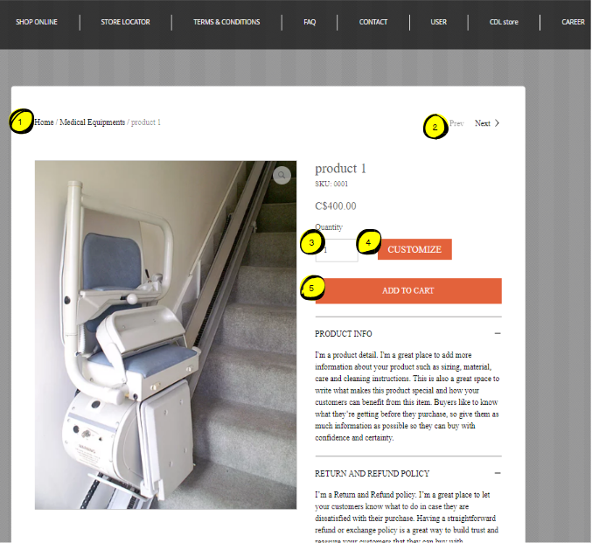

|  |  |  |  |  |
| --- | --- | --- | --- | --- |
| Number | Object Type | Default Text | Behaviour | Comments |
| 1 | Link ` | None | Touch/Click | Go to desired Page |
| 2 | Button | Pre/Next | Touch/click | Go to Pre/Next Product |
| 3 | Text Input | None | Touch/Input | Enter Number of same product |
| 4 | Customize | Button | Touch/Click | Customise a product |
| 5 | Add to Cart | Button | Touch/click | Add Product to cart |

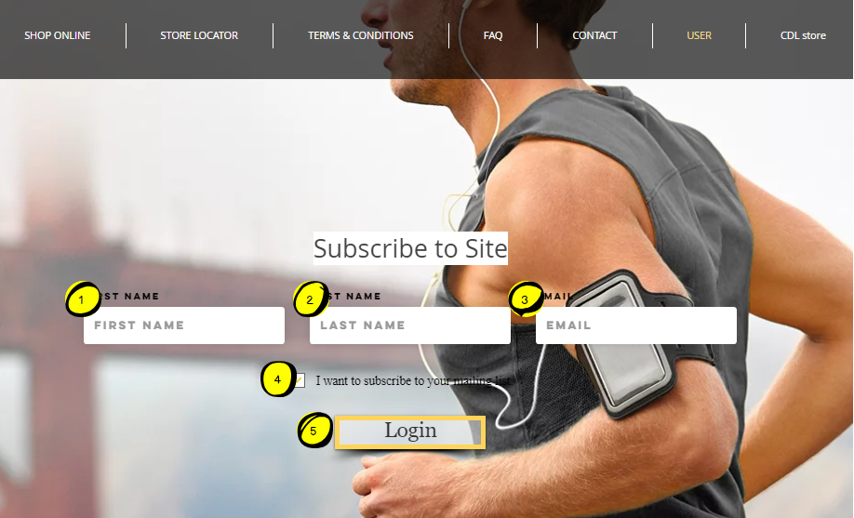

|  |  |  |  |  |
| --- | --- | --- | --- | --- |
| Number | Object Type | Default Text | Behaviour | Comments |
| 1 | Text Input | First Name | Touch/Input | First Name Input |
| 2 | Text Input | Last Name | Touch/Input | Last Name Input |
| 3 | Text Input | Email | Touch/Input | Email Input |
| 4 | Checkbox | Button | Touch/Click | Continue being Subscriber |
| 5 | Login | Button | Touch/click | Continue Login |

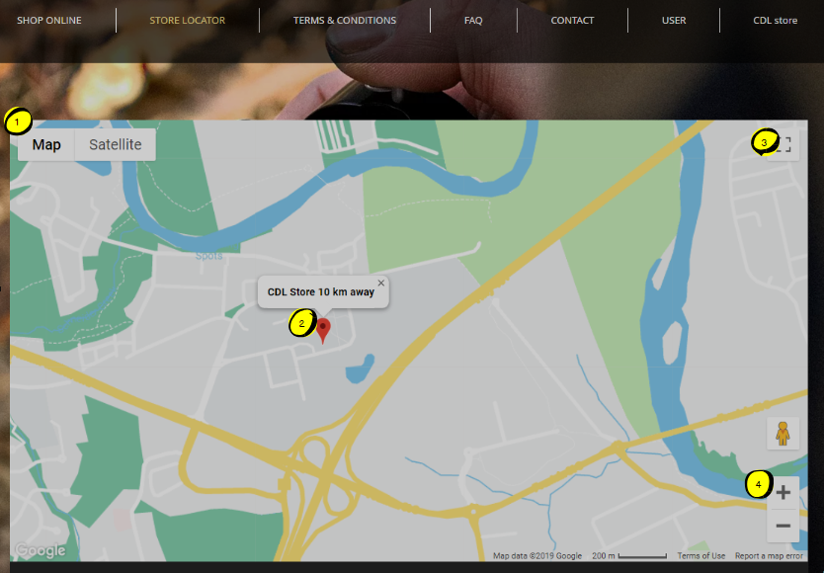

|  |  |  |  |  |
| --- | --- | --- | --- | --- |
| Number | Object Type | Default Text | Behaviour | Comments |
| 1 | Button | Map|Satellite | Touch/Click | Select different View |
| 2 | Icon | None | None | Shows location of store |
| 3 | Button | None | Touch/Click | Full screen |
| 4 | Button | None | Touch/Click | Zoom In/ Zoom Out |

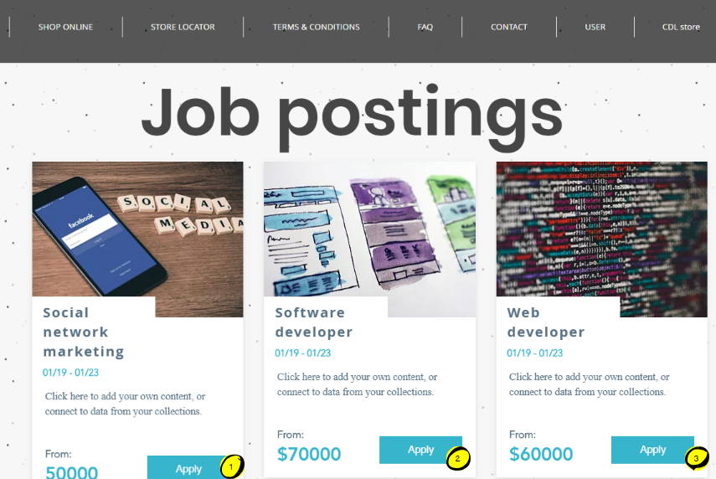

|  |  |  |  |  |
| --- | --- | --- | --- | --- |
| Number | Object Type | Default Text | Behaviour | Comments |
| 1 | Button | Apply | Touch/Click | Apply for jobs |
| 2 | Button | Apply | Touch/Click | Apply for jobs |
| 3 | Button | Apply | Touch/Click | Apply for jobs |

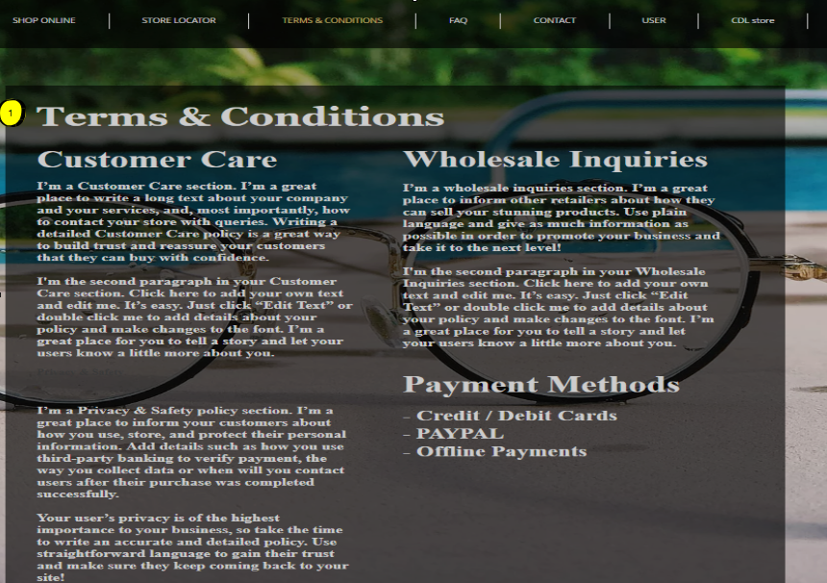

|  |  |  |  |  |
| --- | --- | --- | --- | --- |
| Number | Object Type | Default Text | Behaviour | Comments |
| 1 | Text | None | None | CDL T&C |

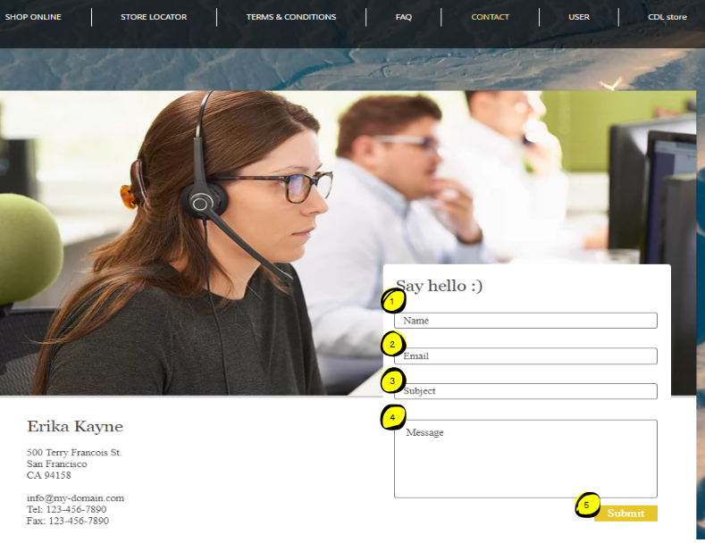

|  |  |  |  |  |
| --- | --- | --- | --- | --- |
| Number | Object Type | Default Text | Behaviour | Comments |
| 1 | Text Input | Name | Touch/Input | Enter name |
| 2 | Text Input | Email | Touch/Input | Enter Email |
| 3 | Text Input | Subject | Touch/Input | Enter Subject |
| 4 | Text Input | Message | Touch/Input | Enter Message |
| 5 | Button | Submit | Touch/Input | Submit the comment |

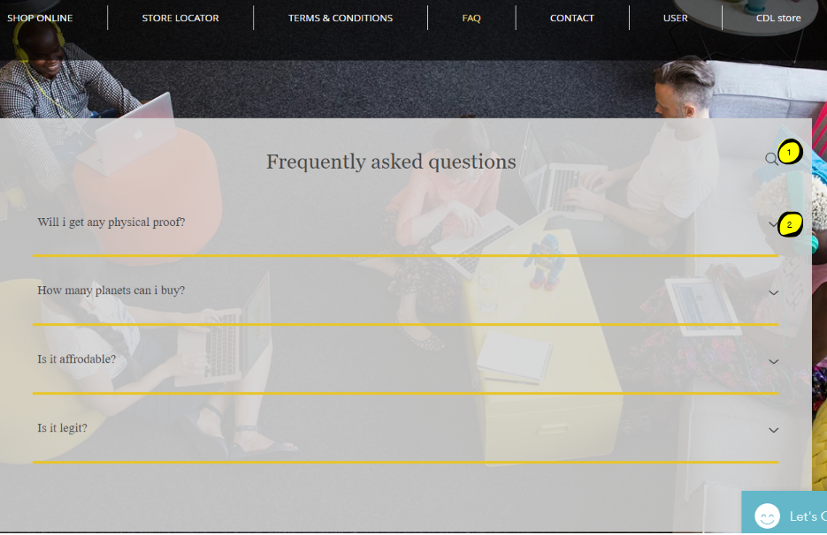

|  |  |  |  |  |
| --- | --- | --- | --- | --- |
| Number | Object Type | Default Text | Behaviour | Comments |
| 1 | Button | None | Touch/Click | Search for FAQs |
| 2 | Button | None | Touch/Click | Drop down Answer |

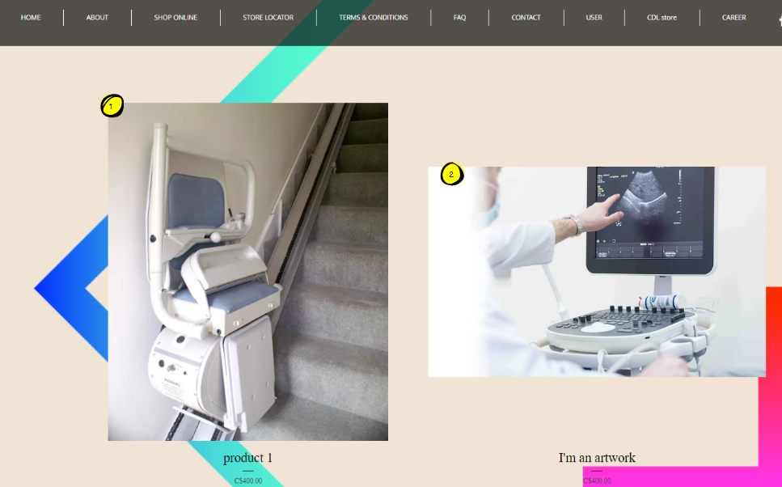

|  |  |  |  |  |
| --- | --- | --- | --- | --- |
| Number | Object Type | Default Text | Behaviour | Comments |
| 1 | Button | None | Touch/Click | Select Product 1 |
| 2 | Button | None | Touch/Click | Select Product 2 |

# E-Commerce Advantage and Disadvantage

## E-Commerce:

E-commerce, known as electronic commerce, is used to buy or sell any product online which also include transfer of money to complete the transaction. Therefore, it is a type of commercial transaction that can be done using the internet. E-commerce can take place in various forms between consumers and business.

There are mainly four kinds of E-commerce models:

1. Business to Business: In this, a business sells its products to other business.
2. Business to Consumer: In this, a business sells its products to one or more consumers.
3. Consumer to Consumer: In this, a consumer sells its product to other individual consumer.
4. Consumer to Business: in this, a consumer sells his/her own products to business.

## Benefits of using E-commerce:

1. Lower commercial cost
2. Global Reach
3. Automated Inventory Management
4. Location Independent
5. Can do business 24/7
6. Easy to find best sellers
7. Easy access to customer’s data
8. Easy to scale business

## Drawbacks of E-commerce:

1. Site crash may take place
2. Customers can not try products before they buy
3. Shipping cost
4. Have to wait till shipping of product
5. High competition among various online sites

## Challenges

In theory, every aspect about the ecommerce sounds rosy at first but the reality is something different. E-commerce has its perk as well as many constraints. There are many important pitfalls such as privacy concern, loss of data, theft of data that one might face.

1. Trust: Trust is a pretty important factor in ecommerce.
   * Can the customer trust the product? Will the product be the same as displayed in the picture? Can a customer trust the quality of product?
   * Can a customer trust the ecommerce company with its personal and important data?
2. Technical challenges: This is always a lingering problem. Technical issues can creep in any time and the potential damage can range form few hours of downtime to potentially shuting down the site.
3. No physical presence: A lack of physical presence can be both a benefit and a downfall since the customers cannot directly see or feel your products.
4. Initial investment: One of the biggest struggle with an ecommerce website is that it requires a lot of upfront capital and investment.

# Web Hosting Survey

## Brief overview

A webhost in simpler term is where our website live or where the website is hosted. Its necessary for all the websites to have a webhost – it is the actual physical location of the website and it provides all the data storage on the websites. Webhost, as the name suggests, the website is hosted on the servers owned and maintained by webhosting service provider.

A lot of factors has to be taken in to consideration whule selecting a webhost provider. Cost offcourse, is one of the key factor. Other critical factors are bandwidth and disk space required which depends upon the size and scale of the website. CDL website will require a lot of space as it will be an e-commerce website with details about the entire CDL’s production lineup as well as the product details and high scale images and graphics. Multiple factors and criteria’s will be taken into consideration before

## Selection criteria

This section lists and details the factors that our team deemed important for selecting, reviewing the Canadian webhosting providers.

1. Cost: Cost will be the most critical factor but cost alone is not enough to determine whether a webhost would be according to our requirement. Features combined with the cost will become the key deciding factor for the service provider.
2. Security: Our team has sortlisted security as the major criteria because It is utmost important to have a strong and secure network environment supporting the website to protect sensitive data. Our team would be looking for a host provider who offers option for SSL certificate.
3. Backups: CDL’s strategic decision will soon be based on the critical data generated by website and so data backup becomes an important factor.
4. Email: Usually, the webhost providers give the option of creating multiple email addresses using the registered domain name. CDL, we’re assuming, could do with some official email addresses for purposes, such as general contact queries, purchasing queries, technical issues etc.
5. Storage/Bandwidth: CDL e-commerce website will require a lot of data space and bandwidth. The disk space can range from few gigabytes to hundreds of gigabytes. Additionally, its important to plan for the future. There should be enough space and bandwidth available if CDL decides to expand its business and so space becomes an important feature.
6. Databases: All the information that needs to be sourced to the website, whether it is the catalogue details or the ecommerce product pricing, needs to be from a database source. We’ll compare the database options available for each of the webhosts.
7. Support line: Its critical for CDL’s business that the website should be operational 24*7. Website downtime costs a huge revenue lost which CDL can’t afford. So its become crucial that a support tline is available if the website faces any issues. The support hours and the type of support provided will be important in deciding to chose a service provider.

|  |  |  |  |  |  |
| --- | --- | --- | --- | --- | --- |
| **Web Hosting Company** | **Overall Rating** | **Price/Month**  **(on a 3-Year Plan)** | **Disk Space** | **Support** | **Features**  **(PROS)** |
| HostPapa logo |  | $ 8.99 Per month | 100 GB | Phone, Live Chat, Tickets | Great Performance |
| Very affordable |
| Free website Migration and SSL |
| HQ+ servers in Canada |
| Charges in CAD |
| WHCLogo |  | $5 Per month | Unlimited | Phone, Live Chats, tickets | HQ+ servers in Canada |
| Unlimited Disk Space |
| Daily Backups Included |
| 24/7 bilingual support |
| Amazing performance |
| Charges in CAD( Affordable) |
| GreengeeksLogo |  | $9.95 Per month | Unlimited | Phone, Live Chats, tickets | Super Green Hosting |
| Quick and easy Set up |
| Servers in Canada and Worldwide |
| 30 day money back guarantee |
| HostuponLogo | 45rf | $7.95 Per month | Unlimited | Phone, Live Chats, tickets | Unlimited Disk Space |
| Canadian Sales and support |
| Servers in Canada and US |
| Free Domain Name |
| wpengine |  | $35 Per month | Unlimited | Phone, Live Chats, tickets | Highly Specialized Support and High Performance Servers |

Based on the above factors, we set out to find the better web hosting options available out there. The search result was narrowed down to three owing to the comparison of the above-mentioned features as well as numerous reviews posted by their customers. While the above factors taken into consideration have a quantifiable measure, the customer reviews have also been considered to bring this comparison to CDL.

## Our Pick: WHC

# Request for Quotation

## Introduction

CDL is planning to develop and launch a website for their company in order to increase their reputation digitally, to attract more customers and to satisfy the needs of existing customers. It will not only work as a first point of contact, but will also assist in reducing the burden of phone lines and will introduce a new way for customers to order the products they need.

Initially, this website will be launched as a promotional site however, later on ecommerce features will be added in order to sell the products by CDL.

## Procedure for Bidding

Companies can use ‘Techcrusaderconsultant@outlook.com’ email address in order to submit their bids along with the quotes about the available services.

* One company can submit the bid only once.
* There must be privacy for the quotes and numbers.
* To retrieve all the legal documents as well as terms and conditions, CDL must be contacted.
* Deadlines for submitting the bids must be put out in advance.
* Bidders must be updated regarding the status of the requests they have made.
* Changes cannot be made once the submission is done.

## Criteria and Constraints

There are some constraints for the bidders that will be applied in order to complete the project in accordance with:

* Scope
* Time
* Cost

If these constraints would not be followed, there would be some penalties that will be imposed on the bidders.

## Additional Information Requirement

Along with the quotes for the services, there is a need to comprise the detailed information of the company within the bids. The information required to check the background of the company includes:

* Name of the company
* Documents of registration
* Address of the company
* Contact details

## Timelines

|  |  |
| --- | --- |
| Tasks | Date |
| Issue of RFQ | 16 July, 2019 |
| Submission of Bid (Start) | 20 July, 2019 |
| Submission of Bid (End) | 25 July, 2019 |
| Final Output | 10 August, 2019 |

## Features of Website

* Chat Bots
* E-commerce
* Custom Graphics
* Social media Integration
* Screen adaptability

## Time Estimates

|  |  |
| --- | --- |
| Activity | Time (In Hours) |
| Research and Planning | 70 |
| Designing and Prototyping | 100 |
| Content Development | 40 |
| Content Review | 15 |
| Content Publishing | 15 |
| Front-End Development | 75 |
| Back-end systems set up | 60 |
| Testing | 40 |
| Web Host Integration | 15 |
| UAT | 50 |
| Go/Live Production launch | 30 |
| Total | 520 |

## Cost Estimation

|  |  |
| --- | --- |
| Research and Designing | $5100 |
| Prototyping | $3400 |
| Front End Development | $3000 |
| Back End Development | $3400 |
| Testing | $2000 |
| Maintenance | $1000 |
| SEO + Content | $1700 |
| Marketing | $300 |
| Domain Name | $117 |
| Hosting | $150 |
| Total | $20167 |

# Difference Between End-User’s and Customer’s

## Definition of End User:

End user is a person who eventually uses the product even though he is not the one who bought that product. For example, a company have purchased some computers however the end user will be the employee who is going to use that product.

## Definition of Customer:

Customer is an individual who buys the product despite the fact he is going to use that product or not. Therefore, one who performs purchase transaction is considered to be a customer. For example, a boss who buys a computer is a customer even if he is not going to use that computer himself.

## Difference between End User and Customer:

End users can be different from customers mostly in business areas and families because in business or family the one who purchases the product does use that for himself. Therefore, the one who purchases that product is considered to be a customer whereas the individual who uses that product is termed as end user.

For CDL, end-users and customers vary based on the type of product being sold. CDL, initially did not have to distinguish between end-users and customers as the hospitals and health-care companies who bought the medical imaging equipment were the same who were using that as well. CDL was selling those products directly.

However, with the launch of the TrackR, CDL had its first experience as they had not sold that kind of products before that. The TrackR was sent from manufacturing and assembly place to the big box retailers and smaller retailers and then to the users who will be using it. Therefore, for CDL, end users and customers changed. Big box retailers were the customers because they bought the products directly from CDL, but they were not the actual users. Then, those products were further sold to people who were considered to be the end users as they ere the ones who used that products.

If the end users are not the customers, they can have poor experience due to various reasons. This is also the case with CDL as they were not aware about the problems with their TrackR wearable. There was no option to get to know the customer experience.

# Project Plan

## Vision

Our vision is to successfully design, developed, test and deploy a fuctional e-commerce website for CDL products. Our team will perform stakeholder analysis to gather idea’s and requirements for the website. It is our endeavor to actively engage all the stakeholder as well as staff of CDL and integrate all in the development project. Through this project, our team aims to improve the operational process, simplify and streamline process as well as increase the brand image. This project will assist CDL to reach to its formal glory by improving the sales and revenue.

## Deliverables and activities

Our team analyzed all the documents provided to us. We have complied the following list of deliverabeles and task that will be required to achieve in order to successfully developed the website.

With the on-boarding of the app development team consisting of developers, marketers, managers and leads, it is important for CDL to manage the functioning of these departments. In order to see the success of the project, it will be crucial that all the department and team collaborate together to ensure a better website design and content experience. CDL will be required to be on board to achieve the goal

Drafting and designing standards and frameworks for better internal communication among these teams can be greatly beneficial to CDL.

The high-level communication and collaboration guidelines are as follows:

1. Content collaboration: In order to keep the content on the website relevant and up to date, a method needs to be designed to ensure that additional new contents and information are documented and shared. Idea’s from different department needs to be collaborated and further filtered.
2. Frequent meetings: Communication between VPs, CEO, and staff will be crucial to ensure success of the project. Fequent meetings will be held to make sure the project is on track and to ensure that there is no scope creep.
3. Feedback and knowledge transfer sessions: Since the social media marketing team remains a key point of reception for user feedback, it helps to have regular sessions between the two teams. User reports, feedback and expectations which the marketing team identifies will be passed to the development team for reflection and implementation.
4. Follow the marketing plan: Marketing team will need to provide a marketing plan and tactics to market the launch of new website and to reach to mass.
5. Transparency and clarity: The marketing team will work closely with the development team. To make communication a less time-consuming process and avoiding wasting of time, the communication frameworks and guidelines will make sure to make the process more transparent clear and concise.
6. Deployment checks: Before launching of new website, beta testing needs to be performed. Selected user’s and tester will be invited to test the project. Their reviews and suggestion needs to be considered and changes will be made before launching

## Collaboration Plan for Staff

Our team would like that each and every member of CDL participate in the website development project. An idea can come from anywhere, from any person. Our team would collect the opinion and suggestions of each and every staff member as their opinion and suggestion’s matters. We will be dividing our team into groups. Each group will perform elicitation through a one-one meeting, group meeting and online surveys to collect their idea’s and suggestion. The agenda and meeting details will be sent to each participating group a few days prior. After collecting all the suggestions from the staff members, our team will analyze those ideas. Important and useful ideas will be sort listed and documented. The documented ideas and suggestion will be forwarded to the app developer for consideration.

# Website Technology Education Plan.

21st century is an era of technology and the importance of technology in our lives is undeniable No matter the size of your enterprise, technology has both tangible and intangible benefits that will not only help the company make profit and revenue but also helps improve the corporate culture, relationships of business, customer service and customer satisfaction.

## Website Technologies Benefits and its Strategic Use

Productivity:  
Technology has a huge impact on the company’s productivity in business operations. Website Technologies such as online tech support, online customer service, and customer support pages reduces the need for personal attention and increase the productivity of investments in these areas without sacrificing customer experience.

Faster Service and ease of use:  
Web Technologies simplifies the business and its operations. Website technologies such as online money transfers, Web purchasing and Internet file sharing all tend to accelerate the production cycle, making the capitalization, production, sale, and distribution of goods considerably faster.

E-commerce website makes the task of customer quite simplified. From an end user perspective, it can be very convenient to purchase goods and services over the Internet. The process is very quick. End user can purchase any product with just a click, without even leaving the house. Customers can be provided with an abundance of information to make their shopping experience easier as well as receive improved customer service. They will also benefit from the ability to purchase goods and services 24 hours a day, 7 days a week and provide

Better Communication:  
For any company to be successful, it is critical that they maintain a healthy communication pathway with its customer. Websites not only allows to communicate with the customer but also to find answers to their questions after the service hours. Fast shipment options allow businesses to move products over a large geographic area. When customers use technology to interact with a business, the business benefits because better communication creates a stronger public image.

Brand Image:  
The success of any e-commerce company critically relies on the traffic it can generate on its webpage. For customers, it is not very so common to follow a link in the search engine results and land upon an e-commerce website that they never heard of. Customers can rate the products and services, thereby creating a strong relationship with the company. With lots of positive customers’ reviews and product ratings, the company can attract new customers, thereby boosting the sales of the product. The website helps the company to create a trustful and long-lasting relationship with its consumers or end users.

## Training Plan

Objective: The primary objective of the training plan is to educate the executives about the impact and benefits of web technologies on business so that they can take advantage of the technology available and to assist in the decision-making process of the website development.

### Human Resource Executive:

Human Resource executive is responsible for managing and directing the human resource tasks such as hiring and training the new employees. Human resource executive have to play a leading role in the activities related to human resource department. Their duties involve hiring a new employee and train them as per the policies of the company. Therefore, it is very important to give training to human resource executive so that they can perform their task effectively. The guidelines for training Human Resource Executive includes:

1. To train them how to follow the procedure of hiring and training of new employees so that they can hire valuable employees for the company so that they can take company to new heights of success.
2. To train them how to manage meetings with new employees in order to know how they are performing and to encourage them for their work.
3. To train them with proper guidelines so that they can be able to encourage constructive work environment which will be helpful for employees to get their work done in an effective manner.
4. To train them how to respond to requests in a timely manner.
5. To train them on the benefits and use of Career page on the website

### Finance Executive:

Finance executive will be responsible for managing financial tasks of the company. He will be responsible to provide administrative and financial support to the staff of the company. Finance executive helps to prepare the budget and the balance sheets. Therefore, it is important that the finance executive will be trained in a better way. The guidelines to train the finance executive are:

1. To train the finance executive about how to plan the budget and to set the requirements as per the budget.
2. To train how to make and manage the balance sheets.
3. To train how to keep track of bank deposit transactions and payments of the company.
4. To train how to make financial reports monthly as well as annually.

### Facilities Executive:

Facility Executive will be responsible for managing the facilities such as space allocation and preparing facility goals. Facility Executive is also responsible for setting proper workplace that will be helpful in getting productive work. His role also includes managing and making schedule for the maintenance of equipment. Guidelines for training Facility executive are:

1. To train them to manage the schedule for maintaining the equipment.
2. To train them to manage the workspace for better work environment.
3. To train them to plan facility goals in order to get the work done in an effective way

# Web Host Tech Support

Maintenance and upgrade of the website in a timely manner are critical for any business. Failure to maintain the website might result in the website being outdated, reduce website traffic and inconsistent contents. Our team would suggest CDL to outsource the maintenance of website on contract. There are numerous benefits of outsourcing the website maintenance and upgrade task.

## The primary reason why our team would suggest to outsource the maintenance of the website are as follow:

* Keeps focus on the main business: Out-sourcing allows management to concentrate on their core proficiencies and critical objectives to drive the business. Website maintenance and upgrade are quite a time consuming, so instead of worrying about how to do website upgrade, and another task, why not focus on the core business and strategies.
* Reduces Expenses: The company won’t be required to hire any part time or full time in house developer for website maintenance. This will help the company to save some expenses which the company can invest elsewhere as they won’t have to pay any salary, medical care expense, and other benefits
* SEO to increase web traffic: Outsourcing will help the company to increase or maintain their search rank which is critical. Maintenance and addition to the website content from time to time allows the company to attract more users because of better search engine ranking. Professional companies have the SEO professional who helps to achieve a better search engine ranking.
* Effective and Engaging UX/UI: Better user interface design helps the company to enhance user satisfaction. This can be achieved with better design, better flow, by populating content that attracts which encourages visitors to return. Better UX/UI increases brand image and reputation.

The cost of outsourcing depends upon the type of service the company needs. Our team would suggest CDL to outsource the website maintenance to any reliable company.

## Maintenance Process:

There is a multi step process to maintain the website and to keep it up-to-date. The steps involved in maintenance are

* Consistent review of website
* Testing web forms
* Review Analytics and SEO reports
* Security updates and bug fixes
* Renewal of domain
* Backup Checks
* Browser Compatibility Checks
* Review and update legal disclaimers

**Consistent review of website**

Each pages in the website must be reviewed thoroughly to check is there any broken links, load times, formatting, styling, missed content, user interface and user friendly

**Testing web forms**

Contact us, request for information, email us are the web forms which also need to be checked regularly in order to avoid missing business opportunities

**Review Analytics and SEO reports**

In order to review the Website performance website analytics is the best option and CDL should bring with KPI’s to measure the performance of their website

**Security updates and bug fixes**

To update software, install patches and security updates both developer and webhost provider have to work together to ensure all the back systems work well. There is a possibility to get website attacks if there is a failure in security updates

**Renewal of domain**

Domain name must be renewed annually in order to avoid expiration

**Backup Checks**

We have to make sure whether the content and data on the website is backed up regularly though its webhost provider’s responsibility

**Browser compatibility checks**

It is good to check whether the website is worked well on the different versions of the web browser and all should be updated regularly

**Review and update legal disclaimers**

The terms of sale, privacy policy, terms and conditions need to updated according to the company’s policy

# Risk Management Plan

## Overview

A website has lot of things to taken into consideration. Apart from the projects risk itself which arisen from team and stakeholder, TRACKR wearable also have certain risk.

Main Concern of CDL is along with the website they have to sell the TRACKR online. CDL has tracked both huge and small distribution of TRACKR devices to the retailers. Retailers also had huge stock of these device to sell in shop. So CDL gave to consider retailer’s risks as well when they launch the products in online. They have to balance out their plan without affecting retailers

## Identifying Risks

Proper approach should be followed to identify the risk and to keep track of the risk for future lessons. The project team of the website must be in the regular contact with the executive team to understand whether they are in the right track and also provide updates

Development team is responsible for handling the technical issues that can be monitored and informed to project management team

Each risks that identified must be entered in risk log/register and that should be assigned to a team member to analyse and handle it. Filtering and categorizing the risk can be done by project managers. They also have to accomplish and organise the team manager’s effort.

## Performing and Prioritizing risk assessment

It is mandatory to keep track of the project which can be achieved by regular meetings with team members and stakeholders. Risk must be weighted after it is identified based on its severity like high, medium and low

## Tracking and Monitoring

The risk identified should be tracked and monitored in the regular interval of time who identify whether it is impacting the whole project even it got fixed or got other impacts when it is fixed. Monitoring risk helps to avoid failure at the last moment

## Risk Register

|  |  |  |  |  |
| --- | --- | --- | --- | --- |
| S. No | Risk | Description | Impact | Possibility |
| 1 | Website Crash | Website stope serving data and got corrupted | Medium | High |
| 2 | Financial plan- Budgeting | Due to many reasons, budget may increased when compared to planned/scheduled | Medium | Medium |
| 3 | Lack of Management Support | Management doesn’t shows any interest in adding new features | Medium | High |
| 4 | Lack of Attention | Customer shows less attention in visiting website | High | High |
| 5 | Lack of Consumer Management | There is no support for consumer after sales | Low | High |
| 6 | Behind Agenda | Deliverables cannot be completed on time | Medium | Medium |

# How website Technology will support CDL business process?

CDL’s current business process is a lot complicated, time consuming and very outdated. In the 21st century, in an era of modern technology, any business or company which does not have its website can not succeed. Currently, CDL does not utilizes any modern technology in its business process. Company doesn’t not have an website, no social media contact with end user. CDL still uses the traditional old methods for order processing through their call center. Not only the method is outdated but also very time consuming and errorsome. With the help of E-commerce website, CDL order taking process will be simplified. User can view the product, its details, enter their personal details and order with just a single click. This will not only reduce the cost for hiring more people for sales team, but also modernize the process, reducing personal errors and save a lot of time. Similarly, for the medical imagining equipment, potential customer can select the type of equipment they want, contact the tech expert with the customization details and the tech expert will revert back to the potential customers request. Half of the CDL’s business process will be digitalized, leaving less room for error and making it quick.

Website will allow CDL to market its product as all the available products with its details will be available on the website. Potential Customer can just click on the product and find all the details they were searching for. Also, website will improve brand image and boosts its reputation in the market. Website will be loaded with the details of the rich and proud history of CDL, with its vision and mission statement. HR process will be modernized as well, as a carrer section will be added on the webpage where the job posting can be posted. This will help CDL to get mass application and ease the HR process as well.

Similarly for the end user support, website will have a section of FAQ’s where all the commonly asked questions along with its solultion will be published. Any user’s or visitor on the webpage can access the FAQ’s and find the solution/ answer for their queries. This will reduce the traffic for the customer service call center. A Chatbox assistance feature will also be added to the website which will chat with the customer and help them find the answer. This will boost the customer service as any user’s can inquire for product or tech support 24*7.

For the customer’s who likes to view the product before buying, a store locator feature will be added on the website which will provide the location of the retailer’s store where CDL’s product are sold.

Overall Business process will be simplified and mordernized with the help of website technologies and the features on the website.

# Project Measure of Success

* The solution should be developed in time.
* The solution should meet the expectation of the stakeholders and end users
* The solution should meet the success criteria defined.
* There should be no or limited scope creep.

# Website Success Criteria

* User-friendly Navigation and Design
* Visual Hierarchy
* Bounce Rate
* Subscriptions & Social sharing
* Consistency
* Accessibilitys

# Conclusion

Previous CDL website was outdated, with improper content and product description was no longer in use since 2014. As customers are not attracted to the website because of the lack of options and, specifications and developing is a website to CDL is a great step to gravitate the customers to CDL because of the bankruptcy problems. There was an dire need for an ecommerce website to take business into a new direction. Modern technology usage to run business provides edge over competitors. We as a team has applied some techniques like social media marketing and website success criteria to make sure the website is as good as today’s generation website. Many specialized features were added as per the business requirement. The website design is rich in context, graphics, high end pictures as well as an appealing UX design This approach is cost effective and website attracts visitors. We as junior analyst has added some features to make sure every product and its related information is added to the website and made the process of ordering and customer service easy to handle. Customers can now easily place order on the website as easy as placing order on any other e commerce website.

# Tools and Techniques

## Team Contract

|  |  |  |  |  |
| --- | --- | --- | --- | --- |
| **Team** | | 4 | | |
| **Team Goal/Objective** | | | | |
| Understand the CDL case study on the CDL website requirement, to identify your key issues and needs and propose solutions to address each of them within the established time, meeting the requirements described. | | | | |
| **Team Roles and Responsibilities** | | | | |
| **Project Manager Role** | | | | |
| * Managing the project team, assigning the tasks to the team members, organizing the tasks according to their schedule and guiding the team on what needs to be done and what rules need to be followed. * Organize team activities * Manage the progress of the project * Ensure a positive environment within the team group | | | | |
| **Responsibilities (Specific**): | | | | |
| * Responsible for scheduling and leading team meet up | | | | |
| **Team Member Role** | | | | |
| Attending the meetings conducted, discussing issues and suggesting improvements. Completing the task and taking responsibility of work allotted | | | | |
| **Responsibilities (Specific**): | | | | |
| * Mutual Agreement   • Allotting task equally and assisting other team members to accomplish the task if needed | | | | |
| **Team Protocols** | | | | |
| **Code of Conduct**: As a Team, we will: | | | | |
| * All the members will be taught concerning the business related information to settle on better decisions and to compose better contemplations. * All members will recognize that the errand manager has the last say in fundamental administration. * Will catch up on most ethically course possible without isolating on any grounds to pester anyone, and to finish the work most ideal way possible. | | | | |
| **Participation**: We will: | | | | |
| * Be always prepared for the meetings in terms of Case Study updates * Share our ideas and listen to the team members’ ideas * Take initiative in participating in the group tasks * Have the same work burden to be fair with all team members. * Listen to other members, and after listening, give non-judgmental feedback * Be clear and straightforward * Avoid interrupting while one person is talking during the meetings * Communicate during team meetings and through telephone calls | | | | |
| **Communication**: We will: | | | | |
| * Communication will be effective and fair to advance morals. * Work load will be similarly relevant among team mates * Communication will be transparent and would be over the phone or advance the discussion * Unless defined, all the discussion will be in and around aims and objectives | | | | |
| **Problem Solving**: We will: | | | | |
| * Follow the instructions of the Case Study to avoid making wrong decisions * Recognize other ideas that are better for the group, even if they are different than yours * Research possible solutions that could help to solve the problem | | | | |
| **Meeting Guidelines**: We will: | | | | |
| * Avoid smartphones use during meetings. Laptop use is allowed only for research and presentation purposes. * Avoid personal talks during the meetings * Meetings will be held previously to the date due for the submissions * Meetings will be called by Scribe and he/she will send the meeting's agenda. | | | | |
| **Team Conditions for Reward and Penalty** | | | | |
| **Reward** | | | **Penalty** | |
| RACI will be marked fairly | | | RACI will reflect decrement in accountability | |
| **Team Members\*** | | | | |
| **Name  (Last, First)** | **Role** | | **Email  (@abc.com)** | **Date (MM/DD/YY)** |
| Vaibhav Solanki | Project Manager | | [Vsolanki6896@conestogac.on.ca](mailto:Vsolanki6896@conestogac.on.ca) | 6/26/2019 |
| Ruhi Ruhi | Communication Specialist | |  | 6/26/2019 |
| Gayathri | Program Manager | |  | 6/26/2019 |
| Gurpreet Singh | Scribe | |  | 6/26/2019 |
| Narinder Singh | Scribe | |  | 6/26/2019 |

*Completion of this section constitutes said Team Member’s acceptance of this Contract.

## RACI



## WBS



## Gantt Chart



# References:

(n.d.). Retrieved from <https://conestoga.desire2learn.com/d2l/le/content/270723/viewContent/5660741/View>

(n.d.). Retrieved from <https://conestoga.desire2learn.com/d2l/le/content/270723/viewContent/5660742/View>

(n.d.). Retrieved from <https://conestoga.desire2learn.com/d2l/le/content/270723/viewContent/5660744/View>